**Performance of Pairs Trading Strategies Based on Various Copula Methods**

Sun Yufei

Department of Quantitative Finance, Faculty of Economics, University of Warsaw

**Abstract**

Our study provides a comprehensive and rigorous evaluation of the performance of several pairs trading strategies—namely, the distance method, individual MPI copula, and mixed copula approaches—across the entire Chinese equity market from 2005 to 2024, incorporating time-varying transaction costs. For the copula-based strategies, we implement a computationally efficient two-step pairs trading approach to enhance practical applicability. In terms of economic returns, the distance, MPI copula, and mixed copula strategies yield mean monthly excess returns of 84, 30, and 25 basis points before accounting for transaction costs, and 81, 23, and 15 basis points after transaction costs, respectively.

Our findings reveal that the DM consistently delivers higher monthly returns than the copula-based method across both economic and risk-adjusted metrics. However, the copula approach exhibits noteworthy attributes: it maintains a stable number of trading opportunities even when the DM's opportunities decline, and its unconverged trades demonstrate higher risk-adjusted performance compared to other strategies. Notably, the Student-t copula emerges as the most suitable model for capturing the dependence structure among stock pairs in the Chinese market, owing to its flexibility in modeling both positive and negative correlations and accounting for fat tails in return distributions. While the DM outperforms in terms of returns, the copula-based strategy offers stability and resilience, particularly in volatile market environments. By enhancing the ratio of converged trades and implementing mechanisms to limit losses, the copula-based approach holds promise for improving overall performance. These results underscore the potential of sophisticated pairs trading strategies to provide valuable diversification benefits and risk mitigation, especially during periods of significant market turbulence.

**Keywords:** Pairs trading; MPI Copula; Mixed Copula; Quantitative strategies; Statistical arbitrage

**TABLE OF CONTENTS**

**1. Introduction** 3

**2. Literature review** 7

2.1 Distance Method 7

2.2 Copula Method 9

**3. Data** 10

**4. Methods** 11

4.1 The Distance Method 11

4.2 The Mispricing Index Copula Method 12

4.2.1 Method Framework Overview 12

4.2.2 Trading Strategy 15

4.3 The Optimal Copula Method 16

4.3.1 Method Framework Overview 16

4.3.2 Trading Strategy 17

4.4 The Mixed Copula Method 18

4.4.1 Method Framework Overview 18

4.4.2 Estimation of Mixed Copula Parameters 19

4.5 Transaction Costs 20

4.6 Return Calculation 20

**5. Results** 21

5.1 Profitability of the Strategies 21

5.2 Risk Adjusted Performance 28

5.3 Risk Characteristics of Pairs Trading Strategies 32

5.4 Robustness and Sensitivity Analysis 35

5.4.1 Varying Opening Thresholds 35

5.4.2 Varying Number of Pairs Traded 37

5.4.3 Varying Trading Period 42

5.4.4 Varying Market Capitalization 47

5.5 Sub-period Performance Analysis 51

5.6. Crisis Versus Non-Crisis 56

**6. Conclusion** 59

**Reference** 61

# **1. Introduction**

Over the past twenty years, the global markets have experienced two significant bear markets—the bursting of the high-tech bubble and the subprime mortgage crisis. These events have posed serious challenges to traditional financial theories. Many investors suffered substantial losses during these crises, forcing some to delay their retirement plans. The volatility and uncertainty of the markets have highlighted the limitations of traditional portfolio management methods, such as the mean-variance optimization theory proposed by Markowitz (1952), in safeguarding investments against systemic risks. Consequently, market participants have begun to question the validity of these widely adopted frameworks and have shown a growing interest in specific long-short equity strategies that are market-neutral. Such strategies aim to minimize exposure to systematic market risks and achieve stable returns even in turbulent market conditions.

Pairs trading is a statistical arbitrage strategy that relies on historical price data and contrarian principles. The core of this strategy is to identify two stocks with a strong historical co-movement. When the prices of these two stocks deviate significantly from their equilibrium, i.e., when the spread between them widens, the investor simultaneously takes a short position in the relatively overvalued stock and a long position in the relatively undervalued stock. This approach essentially bets on the convergence of the stock prices back to their historical equilibrium. The strategy has gained substantial attention in finance due to its potential to generate positive and low-volatility returns that are largely uncorrelated with broader market movements.

The origins of pairs trading can be traced back to Wall Street in the mid-1980s, when Nunzio Tartaglia, a former astrophysicist, assembled a team of physicists, computer scientists, and mathematicians to develop market-neutral or long-short strategies using advanced statistical models and automated trading systems. However, the strategy gained widespread recognition following the influential study by Gatev et al. (2006), which introduced the "distance method" (DM) as a systematic approach to implement pairs trading. Since then, pairs trading has become a fundamental tool in quantitative finance and continues to be widely researched and applied in various market environments.

Gatev et al. (2006) demonstrate that the Distance Method has historically generated significant profits over extended periods. However, subsequent studies, such as Do and Faff (2010), indicate a downward trend in its profitability. They attribute this decline to a reduction in arbitrage opportunities in recent years, reflected by an increasing proportion of pairs that deviate but fail to revert to their equilibrium. Further, Do and Faff (2012) argue that after accounting for trading costs, the Distance Method becomes largely unprofitable after 2002. Similarly, Jacobs and Weber (2015) show that the profitability of the Distance Method exhibits substantial time variation. Zhang and Urquhart (2019) find the profitability of the pair trading strategy (PTS) is somewhat sensitive to market conditions, most notably, the strategy is more profitable during longer-term market turbulence.

Despite these findings, alternative techniques such as copula and mixed copula models have been proposed for statistical arbitrage. While these methods have been briefly mentioned in the pairs trading literature, their effectiveness has not been thoroughly evaluated. Thus, the primary objective of this study is to conduct an in-depth performance analysis of two advanced pairs trading strategies, namely the copula and mixed copula approaches, using a long-term and comprehensive dataset. In particular, this research places greater emphasis on exploring various copula-based methods to assess their effectiveness. Furthermore, this study investigates whether the profitability of these more sophisticated strategies has experienced a similar decline over time and examines the risk factors that may influence their performance.

Pairs trading strategies typically involve two stages: the first stage is the method used to select pairs, and the second stage involves the criteria for opening and closing positions. In the traditional Distance Method, stocks with highly correlated historical price movements are grouped into pairs and are traded when their price spread deviates beyond a predetermined threshold. This strategy has been extensively tested using a broad range of datasets, diverse securities, and across various financial markets (e.g., Andrade et al. 2005; Gatev et al. 2006; Perlin 2009; Do and Faff 2010; Broussard and Vaihekoski 2012; Do and Faff 2012; Jacobs and Weber 2015; Zhang and Urquhart 2019; Gupta and Chatterjee 2020).

In contrast, in the context of copula-based pairs trading, Xie and Wu (2013) proposed a copula strategy, while Wu (2013) assessed its performance using three pre-selected pairs. Xie et al. (2014) extended this analysis by testing 89 U.S. utility stocks over a period of less than ten years. Fernando et al. (2017) propose an alternative investment strategy for pairs trading using Archimedean copulas in order to cover a wider range of tail dependence patterns and apply it to the S&P 500 stocks from 1990 to 2015.

This study aims to expand the existing literature by comprehensively evaluating the performance of both copula-based and mixed copula-based pairs trading strategies using the iFinD dataset, covering China stock market data from 2005 to 2024. By leveraging around two decades of data and a broad sample of Chinese stocks, this research provides a rigorous assessment of alternative pairs trading strategies. Furthermore, by comparing the performance of copula and mixed copula-based strategies against the traditional DM benchmark, we aim to determine whether these sophisticated approaches offer superior long-term profitability.

Understanding the performance differences between copula and mixed copula-based pairs trading strategies relative to the traditional Distance Method provides important insights into the drivers of pairs trading profitability and the potential causes of the observed decline in DM profitability. One possible explanation is that the market has become more efficient over time, leading to a reduction in exploitable arbitrage opportunities. Alternatively, the decline may be due to the inherent simplicity of the DM, which could have attracted more arbitrageurs and, in turn, increased competition, thereby eroding its profitability. Conversely, the more sophisticated methodologies, such as copula and mixed copula models, may be better suited for capturing complex dependencies and exploiting subtle market inefficiencies that the DM cannot address. Addressing these questions is crucial, as it not only enhances our understanding of the current state of market efficiency but also guides future research for both academics and practitioners. The findings will contribute to the development of more advanced trading strategies that are better equipped to adapt to evolving market conditions and further enhance overall market efficiency.

This study examines how increasing the sophistication of methods used for pair selection and trading can influence the quality and accuracy of the relationships captured between paired assets, and ultimately, the performance of pairs trading strategies (PTS). Theoretically, when two assets exhibit a cointegration relationship, it suggests a stable, long-term equilibrium between them. Exploiting this relationship enables a more precise modeling of their co-movements, which can be leveraged to design a high-performing PTS. Additionally, equities often display asymmetric dependence structures (Longin and Solnik 1995; Patton 2004; Low et al. 2013; Dong et al. 2020). By using copulas to model the dependence structure between two assets, rather than relying on the limitations of the elliptical dependence assumptions in covariance-based models, the resulting PTS can potentially capture these asymmetries more effectively. This flexibility may lead to superior performance compared to simpler strategies, as copulas allow for more nuanced characterizations of the dependency patterns within pairs. However, employing more complex models does not always guarantee better results. These sophisticated models can be prone to overfitting, especially in out-of-sample testing, which may result in poorer performance. Moreover, the increased computational resources required for implementing such mathematically intricate models may outweigh their potential performance gains, thus diminishing the practical applicability of these strategies.

The contributions of this study to the existing literature are fourfold. First, we propose a novel two-step approach to pairs trading that integrates elements from both the Distance Method and the copula techniques, resulting in a computationally efficient framework that can be readily implemented by practitioners. When designing trading strategies, computational speed and efficiency are crucial considerations (Clark 2012; Angel 2014; Brogaard et al. 2014). In our method, stock pairs are initially selected based on the sum of squared differences (SSD). For each selected pair, we apply a variety of copula and marginal models in the copula-based strategy, with model selection guided by AIC and BIC criteria. This approach addresses limitations in previous studies, such as Wu (2013), who only applied copulas to a single pair, and Xie et al. (2014), whose analysis was restricted by a short time span and a limited number of stocks. Unlike Fernando et al. (2017), who only used two mixed copulas, our comprehensive analysis reveals that the student-t copula is the best fit for 61% of the selected pairs, indicating that many stock pairs exhibit fat-tailed dependence structures. This observation underscores the inadequacy of simple linear correlation models in capturing the true relationships between assets.

Second, we conduct an extensive performance evaluation of three distinct pairs trading strategies—mispricing index-based copulas, optimal copulas and mixed copulas—using a dataset that covers the entire U.S. stock market from 1962 to 2014. Previous studies have not empirically tested sophisticated pairs trading strategies beyond the DM using a robust long-term dataset, leaving the long-term performance of these methods largely unexplored. By leveraging a broad and comprehensive sample, this study provides the first in-depth examination of the performance of two relatively new approaches, namely, copula and mixed copula-based trading strategies, over an extended time period.

Third, we assess the performance of these strategies using various economic and risk-adjusted return metrics to determine whether the increased complexity in pair selection and trading criteria leads to enhanced profitability. This analysis addresses recent findings that suggest a decline in the profitability of the DM. Our comparison helps identify whether arbitrage opportunities still exist in the market and if more sophisticated approaches, such as copula-based strategies, are now necessary to capture these opportunities given the increased competition in arbitrage trading.

Fourth, we analyze the performance of these strategies in the context of asset pricing literature, focusing on whether common risk factors such as momentum (Carhart 1997), liquidity (Pástor and Stambaugh 2003), and more recently, profitability and investment patterns (Fama and French 2015) can explain the returns of these pairs trading strategies. This analysis enhances our understanding of whether the profitability of pairs trading is driven by traditional risk factors or by other market anomalies, thereby providing a deeper insight into the underlying sources of profitability in these sophisticated trading strategies.

Our analysis reveals that the economic and risk-adjusted performance of the copula-based method is generally weaker than that of the Distance Method. Among the copula strategies evaluated, the student-t copula shows relatively better performance, whereas the mixed copula does not exhibit any significant advantage in terms of returns. This underperformance of the copula method can be largely attributed to its high proportion of unconverged trades. One positive aspect of the copula method is that, in contrast to other approaches, it has maintained a stable frequency of trades in recent years, leading to more consistent economic performance over time. Our findings also indicate that liquidity is negatively correlated with the returns of each strategy, whereas no such correlation is observed with market returns. This result supports the market neutrality of these strategies. Additionally, even after adjusting for multiple asset pricing factors, including momentum, liquidity, profitability, and investment (as per Fama and French, 2015), the alpha of all pairs trading strategies remains high and statistically significant, underscoring their robustness as alternative investment strategies

The structure of the paper is as follows: Section 2 provides a detailed review of the relevant literature on pairs trading, various copula models. Section 3 outlines the dataset utilized in this study. The research methodology is described in Section 4. Section 5 presents the empirical results, while Section 6 concludes the paper by summarizing the main findings and discussing their implications.

# **2. Literature review**

## 2.1 Distance Method

Research on PTS is generally categorized under the broader field of "statistical arbitrage." Statistical arbitrage encompasses strategies that utilize statistical models or methods to identify and exploit apparent mispricings between assets while maintaining a level of market neutrality. Gatev et al. (2006) conducted one of the earliest comprehensive studies on pairs trading, examining the performance of the most widely used and simplest approach, the Distance Method, using CRSP stocks from 1962 to 2002. Their findings indicate that the DM yields an average monthly excess return of 1.3% for the top five unrestricted pairs and 1.4% for the top 20 pairs, before accounting for transaction costs. Furthermore, when restricting the selection of pairs to stocks within the same industry, they document monthly excess returns of 1.1%, 0.6%, 0.8%, and 0.6% for the top 20 pairs in the utilities, transportation, financial, and industrial sectors, respectively. This study provides an unbiased assessment of the strategy’s effectiveness, as it employs the simplest form of pairs trading that is commonly utilized by practitioners. To address concerns of data-mining, Gatev et al. (2006) re-evaluated their strategy after an additional four years and confirmed its continued profitability, thereby strengthening the robustness of their findings.

Do and Faff (2010, 2012) build upon the work of Gatev et al. (2006) by further analyzing the Distance Method to identify the sources of profitability and the impact of trading costs using CRSP data from 1962 to 2009. Their findings reveal that the performance of the DM strategy was strongest during the 1970s and 1980s, but began to decline in the 1990s. Notably, there were two exceptions to this downward trend, both of which occurred during major bear markets: 2000–2002 and 2007–2009. During these periods, the strategy exhibited strong returns, marking a temporary reversal in its overall profitability decline from 1990 to 2009. The enhanced performance in the 2000–2002 bear market was primarily driven by higher profitability from pairs completing multiple round-trip trades, rather than an increase in the number of such trades. Conversely, the performance spike in 2007–2009 was attributed to a greater number of pairs successfully completing more than one round-trip trade, highlighting a different dynamic in the profitability pattern during the second bear market. After incorporating time-varying transaction costs, Do and Faff (2012) concluded that the DM, on average, does not yield positive returns. However, a subset of four out of the 29 constructed portfolios still showed modest average monthly returns of 28 basis points, equivalent to an annualized return of approximately 3.37%. Furthermore, for the period from 1989 to 2009, the DM strategy remained profitable overall, with most of its gains concentrated in the 2000–2002 bear market. Bowen and Hutchinson (2016) provide the first comprehensive UK evidence based on GGR's strategy as well. Evidence suggests that the strategy performs well in crisis periods, so we control for both risk and liquidity to assess performance.

Several studies have examined the application of the Distance Method for pairs trading across various international markets, time periods, and asset classes (e.g., Andrade et al., 2005; Perlin, 2009; Broussard and Vaihekoski, 2012). Jacobs and Weber (2015) provide a comprehensive analysis of the DM across 34 countries and report that, while the strategy yields positive returns, its profitability varies significantly over time. They suggest that the variation in profitability may be attributed to investors’ tendency to overreact or underreact to new information, which influences the mispricing between assets and drives the performance of the strategy. MIAO and LAWS (2016) analyze the performance of PTS from 12 countries. Their results show that in most countries, the strategy generates positive returns, without evidence of under performance during bear markets. Unlike prior research, they do not ﬁnd that the trading proﬁts diminish over recent years. The pairs trading strategy generates positive returns even after transaction costs. However, the returns deteriorate signiﬁcantly at a higher level of transaction costs. It is also found that the correlation between the returns on their pairs trading portfolios and the returns on the corresponding stock market indexes is low, conﬁrming its role as a diversiﬁer to the traditional long only investments.

PTS fall under the broader category of algorithmic trading, which now dominates the order books of most financial markets. Within this domain, Bogomolov (2013) incorporates elements of technical analysis into pairs trading by utilizing two Japanese charting indicators—the Renko and Kagi indicators. This approach is non-parametric and does not rely on modeling the equilibrium price of a stock pair. Instead, these indicators capture the variability of the spread within a pair, which is used to determine how much the spread must deviate before a trade is considered potentially profitable, assuming a mean-reverting behavior in the pair. The strategy's profitability is dependent on the stability of the spread’s volatility, yielding a pre-cost monthly return of 1.42% to 3.65% when applied to U.S. and Australian markets. Yang et al. (2015) adopt a different approach by using limit orders to model the trading behavior of various market participants, thereby distinguishing between individual traders and algorithmic traders. Their methodology employs an inverse Markov decision process solved through dynamic programming and reinforcement learning to accurately categorize traders’ behaviors. All PTS rely on a predefined threshold that, when crossed by the spread, triggers a trading signal. Zeng and Lee (2014) focus on optimizing this threshold value under the assumption that the spread follows an Ornstein-Uhlenbeck process. They frame this as an optimization problem, aiming to maximize the expected return per unit time. Other studies have also explored deriving automated trading strategies from technical analysis or developing profitable algorithms by integrating concepts from diverse disciplines (e.g., Dempster and Jones 2001; Huck 2009, 2010; Creamer and Freund 2010).

## 2.2 Copula Method

Copulas have gained popularity in financial research due to their flexibility in selecting marginal distributions and their ability to model joint distributions, particularly lower tail dependence. This property has made copulas a widely used tool in risk management (Siburg et al., 2015; Wei and Scheffer, 2015) and asset allocation (Patton, 2004; Chu, 2011; Low et al., 2013; Low, Faff et al., 2016). Okimoto (2014) examines the asymmetric dependence structure of international equity markets, including the U.S., and finds two key results. First, the dependence among global equity markets has shown an increasing trend over the past 35 years. Second, the study highlights strong evidence of asymmetry in both upper and lower tail dependence, demonstrating that the traditional multivariate normal model fails to capture these characteristics effectively. These findings suggest that using standard correlation to model joint behavior, as is common in many quantitative methods, inadequately represents the true relationships between assets and is therefore no longer suitable. This motivates the adoption of copula models in our study to better capture the dependence structure of equity pairs.

The application of copulas in quantitative trading strategies, such as pairs trading, remains relatively underexplored. Some attempts have been made by Xie and Wu (2013), Wu (2013), and Xie et al. (2014) to fill this gap. Wu (2013) argues that the primary limitations of the Distance Method and cointegration-based pairs trading strategies are due to the linearity and symmetry assumptions imposed by correlation and cointegration on the dependence structure between paired assets. Copula models, by contrast, can address these limitations by allowing for more flexible and asymmetric dependency structures. To demonstrate this, Wu (2013) proposes a copula-based pairs trading strategy that measures the relative mispricing between stocks and compares it to the Distance Method and a cointegration-based approach. However, the study is limited by its focus on just three pre-selected industry pairs over a 36-month period, and the strategy is applied only to stocks with the same SIC code, thereby restricting its generalizability to a broader universe of pairs.

Xie et al. (2014) extend this analysis by applying a similar copula-based methodology to a larger dataset of 89 utility stocks from 2003 to 2012. Their results show that the copula-based strategy outperforms the Distance Method used by Gatev et al. (2006), and that it generates fewer trades with negative returns compared to the DM. Despite these promising results, the copula-based studies, much like those employing cointegration methods, suffer from a common shortcoming—namely, the lack of robust empirical testing across a large set of stocks and over a sufficiently long sample period. This limitation prevents a comprehensive evaluation of the strategy's long-term performance and its robustness in diverse market environments.

For more recent studies, Fernando et al. (2017) demonstrate that the Copula-GARCH strategy significantly outperforms the traditional Distance Method in terms of returns and Sharpe ratios when applied to S&P 500 stocks from 1990 to 2015, especially under more flexible trading conditions. Additionally, the Copula-GARCH approach offers more trading opportunities and exhibits positive, statistically significant alphas even after controlling for various risk factors. Gholam et al. (2020) constructs a hypothetical portfolio of stock pairs in the Toronto Stock Exchange (TSX) and compares the profitability of distance, cointegration, and copula-based trading strategies from January 2017 to June 2020. The results indicate that the copula method yields the highest profitability, and its performance remains robust even during the COVID-19 crisis. For mixed copula method, Fernando et al. (2023) introduce an alternative pairs trading strategy using Archimedean copulas to capture a wider range of tail dependence patterns, applied to S&P 500 stocks from 1990 to 2015. Results indicate that the mixed copula approach generates higher risk-adjusted returns and lower drawdown risk compared to the traditional Distance Method, even after accounting for trading costs. Specifically, the mixed copula method yields a mean annualized value-weighted excess return of 3.68% for the top 5 pairs, compared to 2.30% for the Distance Method, with Sharpe ratios of 0.58 and 0.28, respectively. The strategy also demonstrates a higher probability of positive returns across various market conditions, outperforming the Distance Method, particularly during periods of stronger joint tail dependence.

# **3. Data**

Our dataset consists of daily stock data from the iFinD database, covering the period from January 1, 2005, to June 28, 2024, spanning 7118 days (233 months) and including a total of 5612 stocks. The selection criteria and methodology used to construct the sample are consistent with those employed in my previous study. To minimize trading costs and avoid potential complications, we have further refined the sample to include only liquid stocks by excluding the bottom decile of stocks by market capitalization in each formation period. Similarly, stocks priced below 1 RMB (YUAN) during the formation period are also excluded. To enhance the robustness of our results and better replicate real-world trading conditions, we additionally filter out stocks that experience at least one non-trading day in any formation period within the corresponding trading period. Overall, our dataset construction aligns closely with the standards set in both my previous research and Do and Faff (2012).

# **4. Methods**

Pairs trading is a mean-reverting, contrarian investment strategy based on an assumed price relationship between two securities. This strategy involves taking long and short positions simultaneously—buying the undervalued security while short selling the overvalued one—to exploit short-term deviations from their expected relationship. Once the price relationship reverts to its mean, both positions are closed, allowing the investor to realize profits.

In this study, we evaluate the performance of four distinct pairs trading strategies (PTS) using data from the iFinD database, covering China stocks from 2005 to 2024. For each strategy, we employ a six-month trading period, during which the strategy is executed based on parameters estimated over the preceding 12 months, referred to as the formation period. These strategies are implemented on a monthly basis without waiting for the current trading period to complete, resulting in six overlapping portfolios, with each portfolio corresponding to a trading period initiated in a different month.

In the DM, outlined in Section 4.1, potential security pairs are ranked based on the sum of squared deviations of their normalized prices during the formation period. Once the pairs are established, the spread between the two securities is monitored throughout the trading period. If the spread deviates beyond a predetermined threshold, this triggers the opening of simultaneous long and short positions. We use this strategy as our primary benchmark to assess the performance of the copula and mixed copula-based pairs trading strategies.

Our copula-based strategy is specifically designed to enhance computational efficiency, making it practical for implementation by traders. This approach combines elements of the Distance Method with the copula framework. Stock pairs are first ranked and selected based on the sum of squared deviations, after which a range of marginal and copula distributions are fitted to the selected pairs. Copulas are then employed (as detailed in Section 4.2) to model the dependence structure between the stocks in each pair and to detect deviations from their most likely relative pricing (Xie et al., 2014). To implement trading, we define two mispricing indices to capture the relative overvaluation or undervaluation of the stocks within each pair, which serve as triggers for initiating long-short positions when prices deviate from their estimated fair values. Additionally, we extend our analysis by incorporating mixed copulas to further explore and refine the copula-based strategy.

## 4.1 The Distance Method

In the DM, the spread between the normalized prices of all potential stock pairs is computed during the 12-month formation period. The normalized price is defined as a cumulative return index adjusted for dividends and corporate actions, with a base value of 1 RMB at the start of the formation period. We then select the top N pairs with the lowest SSD to construct the set of nominated pairs for trading in the subsequent 6-month trading period. Additionally, the standard deviation of the spread calculated during the formation period is recorded and used as a key criterion for trading decisions. A single stock can be included in multiple pairs, provided that the other stock in each pair is different.

Our implementation of the DM follows the approach outlined by Gatev et al. (2006), refined by Do and Faff (2010, 2012) and extended by my pervious paper. At the start of each trading period, stock prices are rescaled to a base value of 1 RMB, and the spread is recalculated and continuously monitored. When the spread deviates by two or more historical standard deviations (measured during the formation period), we simultaneously open a long position on the undervalued stock and a short position on the overvalued stock, depending on the direction of the deviation. Both positions are closed once the spread returns to zero, completing a round-trip trade. The pair is then monitored for subsequent divergences, allowing for multiple round-trip trades within the same trading period. Since the opening threshold is consistently set at two standard deviations, pairs with lower spread volatility require smaller deviations to trigger trades, which increases the risk of positions converging at a loss. Additionally, time-varying transaction costs (discussed in Section 4.4) can further impact profitability. We conduct a detailed sensitivity analysis on this issue in Section 5.5.

We employ two distinct SSD selection methods, as described in my previous paper. The first method is defined as the “Top N Pairs in 1st SSD Decile ∩ 1st NZC Decile”, SSD-NZC, which is constructed by taking the intersection of pairs from the first SSD decile with those from the first (1st) Number of Zero-Crossings (NZC) decile. This selection method aims to identify pairs that rank highly in terms of price spread stability (lowest SSD decile) while also exhibiting minimal price reversals (highest NZC decile). The second method is defined as the “Top N Pairs in 1st SSD Decile ∩ 1st Hurst Decile”, SSD-Hurst, formed by intersecting pairs from the first SSD deciles with pairs from the first (lowest) Hurst decile. By selecting pairs that score in both the top SSD deciles and the lowest Hurst decile, these portfolios aim to capture stocks that combine low deviation in price spreads with the highest propensity for mean reversion.

## 4.2 The Mispricing Index Copula Method

### 4.2.1 Method Framework Overview

A copula is a mathematical function that links marginal distribution functions to form their joint distribution, thereby capturing the dependence structure among the marginal distributions. A copula function is defined as a multivariate joint distribution function with uniform marginal distributions:

(4.7)

where for . Now consider a set of random variables ​ with continuous marginal distribution functions . Since any random variable can be transformed into a uniform random variable by applying its cumulative distribution function, i.e., where , we can define the copula function of these random variables as follows:

(4.8)

If the marginal distribution functions ​ and the copula function are differentiable up to the first and order, respectively, the joint probability density function (pdf) can be expressed as the product of the marginal density functions and the copula density function:

(4.9)

where is the copula density function, obtained by differentiating the copula function with respect to each of its arguments:

(4.10)

Equation (4.9) allows us to separate a multivariate distribution into two components: the individual marginal density functions and the copula density function. This decomposition is crucial because the marginal density functions capture the characteristics of the individual distributions, while the copula density function represents the dependency structure between them. Consequently, all dependence properties between the random variables are encapsulated within the copula density function, making it an essential tool for modeling complex dependencies.

Therefore, Copulas offer greater flexibility in modeling multivariate distributions by enabling the independent modeling of each marginal distribution without imposing assumptions on their joint behavior. Furthermore, the selection of the copula is independent of the choice of the marginal distributions, allowing for a more versatile approach to dependency modeling. Unlike traditional methods that often assume linear dependence structures between variables, copulas eliminate this constraint and provide a way to capture more complex dependency patterns. By choosing appropriate copula functions, a variety of dependence structures, including asymmetric dependencies, can be effectively modeled.

Let ​and ​be two random variables with respective marginal distribution functions and a joint bivariate distribution function . Defining and ​, where , the copula function linking these variables is given by . By definition, the partial derivatives of the copula function yield the conditional distribution functions (Aas et al., 2009):

(4.11)

​

The conditional distribution functions ​ and ​ allow us to estimate the probability of one random variable being less than a given value, conditional on the other variable having a specific value. Applying these functions in a PTS enables us to assess the probability of one stock in a pair increasing or decreasing relative to its current price, given the movement of the other stock.

Xie et al. (2016) utilize the property that the partial derivative of the copula function yields the conditional distribution function to propose a measure that quantifies the degree of mispricing. Let ​ and ​ represent the random daily returns of stocks and at time , and ​ and ​ denote their respective realized values at time . The conditional probabilities can be defined as:

(4.12)

where and .

Therefore, these conditional probabilities, and ​, measure whether the return of stock is relatively high or low at time , given the return of stock at the same time and their historical relationship, and vice versa. If , it indicates that the return ​is neither significantly high nor low relative to based on their historical relationship, implying no mispricing. In other words, a conditional value of 0.5 suggests that stock is fairly priced compared to stock on that day.

The above-mentioned conditional probabilities reflect relative mispricing for a single day only. To capture the overall degree of relative mispricing, we define two mispricing indices ​ and ​ for stocks and as and . At the beginning of each trading period, two cumulative mispricing indices ​ and ​​ are initialized to zero and then updated daily according to the following equations:

(4.13)

for . By construction, and ​ are non-stationary time series, and their properties depend on the correlation between ​ and ​. If the correlation is zero, ​ follows a pure random walk, suggesting that statistical arbitrage opportunities are absent. A positive correlation indicates a tendency for ​ to diverge, potentially resulting in losses. Conversely, a negative correlation suggests that tends to revert back to zero when it moves significantly away from the equilibrium, thereby generating profit opportunities. Empirically, ​ may alternate between these behaviors, and as long as the mean-reverting mechanism dominates, the strategy can yield profitable outcomes.

This approach is particularly advantageous because it captures mispricings over multiple time periods, offering insights into how far the prices deviate from their equilibrium. Unlike single-day mispricing indices, cumulative mispricing indices lead to a more stable trading strategy. Positive (negative) values of ​ and negative (positive) values of ​ indicate that stock 1 (stock 2) is overvalued relative to stock 2 (stock 1).

### 4.2.2 Trading Strategy

Similar to the DM, we rank all potential stock pairs based on the SSD-Hurst of their normalized prices during the formation period and select the top N pairs with the lowest SSD values for trading in the subsequent trading period. For each of these selected pairs, we employ the Inference for Margins (IFM) method (Joe, 1997) to fit copula models. We consider a range of copula types, such as Clayton, Frank, Gaussian, Gumbel, and Student-t copulas, conditional probability functions given in table 2. Rather than selecting the optimal copula by maximizing the log-likelihood of each copula density function and evaluating its fit using the Akaike Information Criterion (AIC) and Bayesian Information Criterion (BIC), we will instead compute and analyze the returns generated by each of the five copula models individually. Similar to Rad et al. (2016), we propose the following steps to obtain and using copula-based models.

First, we calculate the daily returns for each stock during the formation period and estimate the marginal distributions of these returns by fitting an appropriate ARMA(p, q)-GARCH(r, s) model to each univariate time series. This process yields the estimated conditional mean and conditional standard deviation for each stock . Using these estimated parameters, we then construct the standardized residuals for each asset and each time , where represents the number of assets and denotes the length of the time series, as follows:

(4.14)

where is the return of asset . Next, we transform the standardized residuals into pseudo-observations defined as , where ​ is the empirical distribution function of the standardized residuals for asset .

Second, after estimating the marginal distributions in the previous step, we proceed to fit a two-dimensional copula model to the data transformed into [0, 1] margins in order to link the joint distribution to the marginals and . Specifically, we define the joint cumulative distribution function as:

(4.15)

where represents the estimated joint cumulative distribution function and denotes the copula function. In this step, we evaluate several copulas, including the Gaussian (Normal), Student-t (T) (elliptical copulas), and a variety of Archimedean copulas such as the Clayton, Frank, and Gumbel copulas.

Third, to measure the degree of mispricing, we compute the conditional probabilities ​ and ​ for each day during the trading period by taking the first derivative of the copula function using the estimated parameters.

Forth, long and short positions in stocks and are established on days when ​and ​, provided there are no existing positions in either or . Similarly, positions are established in and when and , if no positions are currently held.

Fifth, all open positions are closed once reaches ​ or reaches ​, where , ,and ​ are predetermined thresholds. If these thresholds are not met, the positions are automatically closed on the final day of the trading period. Practitioners can freely select these threshold values. However, instead of choosing arbitrary values, we set the trading thresholds to generate a comparable number of trading signals, specifically focusing on the top N pairs in this study. This approach ensures a fair comparison of the performance across different strategies. For our analysis, the thresholds are set as ,, and .

**TABLE 2.** Five Copula Conditional Probability Functions

|  |  |  |
| --- | --- | --- |
| **Copula** |  |  |
| **Student-*t*** |  |  |
| **Clayton** |  |  |
| **Frank** |  |  |
| **Gumbel** | ​ |  |
| **Gaussian** |  |  |

Note: This table shows five conditional probability functions of copulas used in the copula method.

## 4.3 The Optimal Copula Method

### 4.3.1 Method Framework Overview

Building on the mispricing index copula method described in Section 4.2, the optimal copula method seeks to enhance the modeling of dependency structures between stock pairs by selecting the most appropriate copula function for each pair individually. While the mispricing index copula method considers several predefined copulas and analyzes their returns separately, the optimal copula method systematically evaluates multiple copula models for each stock pair and selects the one that best fits the data based on a statistical criterion. This tailored approach allows for a more precise capture of the dependence structures inherent in each stock pair, potentially leading to improved trading performance.

The core idea of the optimal copula method is to fit a range of copula models to the historical data of each selected stock pair during the formation period and choose the copula that minimizes the Schwarz Information Criterion (SIC), also known as the Bayesian Information Criterion (BIC). The SIC penalizes model complexity while rewarding goodness of fit, thus balancing overfitting and underfitting. By selecting the copula with the lowest SIC, we ensure that the chosen model provides the best trade-off between model simplicity and explanatory power for the dependence structure between the stock pair.

### 4.3.2 Trading Strategy

Similar to the DM, we rank all potential stock pairs based on the SSD-NZC of their normalized prices during the formation period and select the top N pairs with the lowest SSD values for trading in the subsequent trading period. For each of these selected pairs, we employ the Inference for Margins (IFM) method (Joe, 1997) to fit copula models. For each of the selected stock pairs, we proceed to fit multiple copula models using their return data from the formation period. The copula models considered include Clayton, Frank, Gumbel, Gaussian (Normal) Copula and Student-t Copula.

The fitting process begins with data preparation, where the log returns of each stock are calculated and aligned to ensure that the return series cover the same time periods without missing values. Following this, the marginal distributions of the returns are estimated by fitting appropriate models, such as ARMA-GARCH, and standardized residuals are computed. After the standardized residuals are available, they are transformed into pseudo-observations within the [0,1] interval using their empirical cumulative distribution functions (CDFs). The next step involves fitting different copula models to these pseudo-observations and calculating the Schwarz Information Criterion (SIC) for each model. The SIC is calculated using the formula , where L represents the likelihood of the copula model, k is the number of parameters in the model, and T is the number of observations. The final step is selecting the copula model with the lowest SIC value for each stock pair. This copula is considered the optimal model for capturing the dependence structure between the two stocks.

With the optimal copula models selected for each stock pair, the trading strategy is implemented during the trading period through several key steps. First, stock prices for both the formation and trading periods are standardized by subtracting the mean and dividing by the standard deviation calculated during the formation period. This standardization ensures consistent scaling of the data across different periods.

Next, the empirical cumulative distribution functions (CDFs) of the standardized returns from the formation period are used to transform the standardized returns from the trading period into pseudo-observations. This transformation maintains the dependency structure learned during the formation period.

For each day in the trading period, mispricing indices are computed by calculating the conditional probabilities using the derivative of the optimal copula function with respect to each margin. The cumulative mispricing indices and are initialized to zero at the start of the trading period. These indices are updated daily by adding the mispricing indices minus 0.5, thus aggregating mispricing signals over time. These cumulative indices serve as the basis for trading decisions.

When the cumulative mispricing indices cross predetermined thresholds, trading signals are generated. If ​ exceeds threshold ​ and ​ is below ​, a long-short position is opened in stocks Y and X. Conversely, positions are opened when is below ​ and ​ exceeds ​, provided no positions are currently held. Positions are closed either when ​ reaches ​ or ​ reaches ​, or at the end of the trading period if no thresholds are met. In this implementation, we set these thresholds to , , and .

## 4.4 The Mixed Copula Method

### 4.4.1 Method Framework Overview

In the previous sections, we explored the use of individual copula models to capture the dependence structure between stock pairs in pairs trading strategies. While selecting the optimal copula for each stock pair enhances the modeling of dependencies, it may still fall short in capturing the complex and diverse dependency patterns that can exist in financial markets. To address this limitation, we introduce the Mixed Copula Method, which employs a mixture of multiple copulas to model the dependence structure more flexibly and accurately.

A mixed copula combines several copula functions, each weighted by a coefficient that reflects its contribution to the overall dependence structure. This approach allows us to capture different aspects of dependency, such as tail dependence and asymmetry, by blending the strengths of various copula models. The flexibility of mixed copulas makes them particularly suitable for modeling the intricate relationships between asset returns, which may not be adequately represented by a single copula.

We define a mixture of d component copulas as follows:

(4.16)

Where is the mixed copula function, ​ represents the set of all possible mixed copulas formed by the convex combination of d copula functions, denotes the copula function in the mixture, is the weight assigned to the copula, satisfying and .

This framework allows us to construct flexible mixed copula models with varying numbers of components, such as two, three, or four copulas. By adjusting the weights ​ and selecting appropriate copula functions , we can tailor the mixed copula to capture the specific dependency characteristics of each stock pair.

Based on our empirical results, we construct four flexible mixed copula models. These four copula models are defined as follows:

1. The mixture of Clayton, Frank, and Gumbel copulas:

(4.17)

1. The mixture of Frank, Gumbel, and Student-t copulas:

(4.18)

1. The mixture of Clayton, Student-t, and Gumbel copulas:

(4.19)

1. The mixture of Clayton, Student-t, and Frank copulas:

(4.20)

In these formulations, , ​, ​, and ​ represent the Clayton, Frank, Gumbel, and Joe copulas with parameters α, β, and δ, respectively. ​ and ​ are the weights assigned to the first and second copulas in the mixture, with being the weight of the third copula.

### 4.4.2 Estimation of Mixed Copula Parameters

To estimate the parameters α, β, and δ, and the weights of the mixed copula models, we employ a penalized maximum likelihood estimation method from Cai and Wang (2014). Specifically, we minimize the negative log-likelihood function augmented with a penalty term that encourages sparsity in the weights. The objective function to be minimized is:

(4.21)

Where, T is the number of observations, is the density function of the copula evaluated at , λ is a tuning parameter controlling the strength of the penalty. is a penalty function, such as the smoothly clipped absolute deviation (SCAD) penalty, with parameter γ.

The inclusion of the penalty term serves to regularize the weights ​, potentially setting some weights to zero and thus selecting a subset of copulas that best explain the dependency structure. This approach helps prevent overfitting and reduces model complexity.

The estimation process begins with transforming the marginal distributions of the stock returns into uniform distributions on the interval [0,1] using their empirical CDFs. This transformation produces pseudo-observations and which serve as inputs for the copula modeling. The next step is to initialize the copula parameters α, β, and δ, as well as the weights ​. These initial guesses provide a starting point for the iterative procedure. An Expectation-Maximization (EM) algorithm is then employed to refine these estimates. During the Expectation step, the current copula parameters are used to update the weights ​ by calculating the expected log-likelihood. In the Maximization step, these updated weights are then used to maximize the penalized log-likelihood function with respect to the copula parameters α, β, and δ.

This EM process is repeated iteratively, and the convergence of the algorithm is monitored by checking whether the change in the estimated parameters falls below a predefined threshold. Alternatively, the algorithm halts once a maximum number of iterations is reached. The EM algorithm is particularly well-suited to this estimation problem, as it efficiently handles latent variables (in this case, the component memberships implied by the weights) and is robust in estimating mixture models.

## 4.5 Transaction Costs

Transaction costs are a critical factor in determining the profitability of PTS. Each full execution of a pairs trade involves two round-trip transactions, and the associated costs also include implicit market impact and potential short selling fees. Given that the cumulative effect of these costs can be substantial, they can significantly reduce the overall profitability of PTS when accounted for properly.

In this study, we utilize a time-varying transaction cost dataset consistent with Do and Faff (2012) and my previous paper. The rationale for this approach is that commissions and stamp duty represent the primary component of transaction costs, and these fees have undergone considerable changes over the past 20 years, which is the time span of our sample. Using a constant commission rate could lead to inaccurate results, thus we adopt the institutional commission rates calculated by Do and Faff (2012), which start at 40 basis points (bps) in 2005 and gradually decrease to 15 bps in recent years for both buy and sell.

Following their methodology, for China stock market, we further divide our study period into two sub-periods and apply different market impact estimates for each: 40 bps for the period from 2005 to 2016, and 15 bps for the period from 2016 onward. Additionally, as our sample excludes stocks with low value and low market capitalization, we assume that the remaining stocks are relatively less expensive to short, and therefore, we do not explicitly include short selling costs in our analysis. To ensure accuracy, we also consider market impact and slippage like my pervious paper at 30 bps for both buy and sell.

## 4.6 Return Calculation

The performance of the four pairs trading PTS is recorded and evaluated using various performance metrics, including different measures of returns. Following the methodology of Gatev et al. (2006) and Do and Faff (2010), we calculate two types of returns: Return on Employed Capital and Return on Committed Capital.

Return on Employed Capital () for month m is defined as the sum of the marked-to-market returns of all pairs traded in that month, divided by the number of pairs actively traded during the period. This metric reflects the actual returns generated by the capital that was employed in trades.

(4.22)

where n is the number of traded pairs.

Return on Committed Capital () for month m is calculated as the sum of the marked-to-market returns of all traded pairs, divided by the number of pairs that were allocated for trading (in our case, N pairs), regardless of whether they were traded or not. This measure is more conservative and reflects the opportunity cost associated with the capital set aside for trading, making it more suitable for reporting returns from a hedge fund perspective.

(4.23)

The strategies are executed on a monthly basis without waiting for the completion of the current trading period, leading to the formation of six overlapping "portfolios" each month. The monthly excess return of a strategy is calculated as the equally weighted average return of these six portfolios. Given that trades do not always start at the beginning of the trading period or close exactly at the end, the full capital may not always be fully utilized. Additionally, some months may experience no trading activity. As idle capital does not accrue interest, the reported performance may be underestimated.

For both the Distance Method and the Copula-based Method, positions are constructed as 1 RMB long–short positions. A 1 RMB long–short position is defined as simultaneously opening a 1 RMB long position and a 1 RMB short position. Since the proceeds from shorting one stock can be used to fund the purchase of the other stock, these positions are effectively self-financing and do not require additional capital. However, for the sake of return calculations, we adopt the standard convention of considering the total value of each long–short position as 1 RMB.

# **5.** **Results**

## 5.1 Profitability of the Strategies

Tables 3 and 4 present key distribution statistics for monthly excess returns of various pairs trading strategies using different copulas, covering the period from 2005 to 2024. The results are divided into two panels: Panel A reports return on employed capital, and Panel B reports returns on committed capital. Since both return measures yield similar results and rankings across strategies, we focus on return on employed capital for the remainder of this analysis.

Before accounting for transaction costs (Table 3, Panel A), the strategies based on SSD—specifically, SSD-Hurst and SSD-NZC—exhibit the highest average monthly excess returns of 0.84% and 0.82%, respectively. These returns are statistically significant at the 5% level, with t-statistics of 2.26 and 2.44. However, these strategies also display extreme skewness, over 9, and kurtosis, exceeding 100, indicating highly non-normal return distributions. The Jarque-Bera test confirms this non-normality with p-values of 0. Among the copula-based strategies, the Gaussian copula method achieves the highest average monthly excess return of 0.30% significantly. It also records the highest Sharpe ratio of 0.23 among all strategies, suggesting superior risk-adjusted performance. The Frank and Student-t copula methods follow closely, with average returns of 0.26% and 0.28% and Sharpe ratios of 0.21 and 0.19, respectively. Other copula methods like Clayton, Gumbel, and Optimal show lower average returns ranging from 0.19% to 0.24%. Their Sharpe ratios are slightly lower, indicating moderate risk-adjusted returns.

After accounting for transaction costs (Table 4, Panel A), average monthly excess returns decrease across all strategies, as expected. The SSD-Hurst and SSD-NZC methods maintain relatively high returns of 0.81% and 0.77%, still significant at the 5% level. However, several copula-based strategies experience notable reductions in returns and statistical significance. For instance, the Clayton Copula’s mean return drops from 0.24% to 0.11%, with the t-statistic falling from 2.61 to 1.33, no longer significant. The Gumbel Copula’s mean return decreases from 0.21% to 0.08%, with the t-statistic declining from 2.90 to 1.14, no longer significant. The Frank Copula’s mean return reduces from 0.26% to 0.16%, with the t-statistic decreasing from 3.03 to 1.84, marginally significant at the 10% level. Despite the decrease, the Gaussian and Student-t copula methods continue to show statistically significant returns after transaction costs. The Gaussian Copula’s mean return reduces from 0.30% to 0.19%, with the t-statistic decreasing from 3.63 to 2.37, remaining significant at the 5% level. The student-t Copula’s mean return drops from 0.28% to 0.23%, with the t-statistic decreasing from 3.41 to 2.69, still significant at the 1% level.

In terms of risk-adjusted performance after transaction costs, the Gaussian and Student-t copula methods maintain relatively high Sharpe ratios of 0.15 and 0.18, respectively. The SSD-Hurst method also shows a Sharpe ratio of 0.20. Other copula methods exhibit lower Sharpe ratios, reflecting diminished risk-adjusted returns. For example, the Clayton Copula’s Sharpe ratio decreases from 0.17 to 0.08, and the Gumbel Copula’s Sharpe ratio falls from 0.16 to 0.07. The Optimal Copula’s Sharpe ratio reduces from 0.16 to 0.08.

The varying performance among the copula-based strategies can be attributed to the distinct dependence structures each copula captures. The Gaussian Copula assumes a normal dependence structure, effectively capturing linear correlations between asset pairs. Its consistent strong performance suggests that linear relationships are prevalent and profitable in the dataset. The student-t Copula captures both upper and lower tail dependence due to its heavy-tailed properties. The strong performance indicates that extreme co-movements in asset pairs contribute significantly to returns, and modeling these tail dependencies enhances strategy effectiveness. The Frank Copula exhibits a symmetric dependence structure without tail dependence. Its moderate performance suggests that while symmetric dependence is somewhat effective, the lack of tail dependence modeling may limit its ability to capture profitable extreme events. The Clayton Copula focuses on lower tail dependence (joint extreme negative movements). The weaker performance implies that joint downturns are either less frequent or less profitable in the context of pairs trading in this dataset. The Gumbel Copula emphasizes upper tail dependence (joint extreme positive movements). Similar to Clayton, its lower performance may be due to the infrequency or limited profitability of joint upturns between asset pairs. The Optimal Copula presumably selects the best-fitting copula for each asset pair. Surprisingly, it underperforms compared to the Gaussian and Student-t copulas. This may be due to overfitting during copula selection, leading to strategies that do not generalize well out-of-sample.

Transaction costs significantly impact strategy performance, especially for copula methods with lower average returns. Strategies like Clayton and Gumbel, which had modest returns before costs, become statistically insignificant after accounting for transaction costs. The reduction in t-statistics and Sharpe ratios highlights that these strategies may not be viable in real-world trading environments where transaction costs are unavoidable. The SSD methods, despite maintaining high returns after costs, carry the risk associated with their highly non-normal return distributions. The extreme skewness and kurtosis suggest potential for large, infrequent losses that are not captured by mean and standard deviation alone.

The differences in performance among copula methods can be explained by their inherent properties. The ability of a copula to model the correct dependence structure between asset pairs is crucial. The Gaussian Copula’s success indicates that linear dependence is a dominant feature in the data. Strategies that capture tail dependence, like the student-t Copula, perform better, suggesting that extreme co-movements play a significant role in pairs trading profitability. Copulas that model asymmetric dependence, such as Clayton and Gumbel, may not align well with the market conditions in the dataset, leading to poorer performance.

In conclusion, the Gaussian and Student-t copula-based pairs trading strategies demonstrate the most robust performance both before and after transaction costs. Their effectiveness can be attributed to their ability to capture the relevant dependence structures—linear and tail dependencies—that are essential in identifying profitable trading opportunities. The underperformance of other copula methods highlights the importance of selecting a copula that aligns with the actual dependence patterns in the data. Strategies that fail to capture these patterns may not only underperform but also become unprofitable after considering transaction costs. Moreover, the significant impact of transaction costs emphasizes the necessity of incorporating realistic trading frictions into strategy evaluation. While some strategies may appear profitable before costs, their viability diminishes once costs are accounted for. Finally, the extreme non-normality of returns in SSD methods suggests that high average returns may come with increased risk of extreme losses. Investors should consider higher moments of return distributions, such as skewness and kurtosis, alongside mean and variance when assessing strategy performance. This analysis underscores the critical role of dependence modeling in pairs trading and the need for strategies that effectively capture the complexities of asset relationships in financial markets.

**TABLE 3.** Pairs Trading Strategies with Various Copulas Monthly Excess Returns before Transaction Costs.

|  |  |  |  |  |  |  |  |  |  |  |
| --- | --- | --- | --- | --- | --- | --- | --- | --- | --- | --- |
| **Strategy** | **Mean** | ***t*-stat** | **Std. Dev.** | **Sharpe** | **z-stat** | **Skewness** | **Kurtosis** | **VaR**  **(95%)** | **CVaR**  **(95%)** | **JB test**  **(p.value)** |
| *Panel A: Return on employed capital* | | | | | | | | | | |
| SSD-Hurst | 0.0084 | 2.26** | 0.0399 | 0.21 | 2.25** | 10.1033 | 120.5140 | -0.0090 | -0.0207 | 0 |
| SSD-NZC | 0.0082 | 2.44** | 0.0408 | 0.20 | 2.43** | 9.0968 | 106.0665 | -0.0174 | -0.0336 | 0 |
| Clayton | 0.0024 | 2.61*** | 0.0143 | 0.17 | 2.60*** | -0.4138 | 2.9655 | -0.0214 | -0.0344 | 0 |
| Frank | 0.0026 | 3.03*** | 0.0128 | 0.21 | 3.02*** | 0.5756 | 6.8005 | -0.0150 | -0.0272 | 0 |
| Gaussian | 0.0030 | 3.63*** | 0.0129 | 0.23 | 3.62*** | -0.1911 | 1.1780 | -0.0180 | -0.0258 | 0 |
| Gumbel | 0.0021 | 2.90*** | 0.0129 | 0.16 | 2.90*** | -0.4994 | 1.3553 | -0.0213 | -0.0296 | 0 |
| Student-t | 0.0028 | 3.41*** | 0.0146 | 0.19 | 3.42*** | -0.5746 | 2.2493 | -0.0220 | -0.0357 | 0 |
| Optimal | 0.0019 | 2.33** | 0.0116 | 0.16 | 2.32** | -0.9099 | 3.2471 | -0.0174 | -0.0273 | 0 |
| CFG | 0.0020 | 2.33** | 0.0114 | 0.17 | 2.32** | -0.4443 | 0.8605 | -0.0181 | -0.0257 | 0 |
| CJF | 0.0023 | 2.79*** | 0.0125 | 0.19 | 2.78*** | -0.4243 | 2.6056 | -0.0183 | -0.0279 | 0 |
| CJG | 0.0023 | 2.82*** | 0.0127 | 0.18 | 2.82*** | -0.2754 | 1.6407 | -0.0218 | -0.0290 | 0 |
| FJG | 0.0025 | 3.07*** | 0.0124 | 0.20 | 3.06*** | -0.3048 | 2.1104 | -0.0150 | -0.0263 | 0 |
| *Panel B: Return on committed capital* | | | | | | | | | | |
| SSD-Hurst | 0.0082 | 2.21** | 0.0395 | 0.21 | 2.20** | 10.1453 | 121.1081 | -0.0088 | -0.0204 | 0 |
| SSD-NZC | 0.0081 | 2.39** | 0.0407 | 0.20 | 2.38** | 9.1478 | 106.8560 | -0.0174 | -0.0335 | 0 |
| Clayton | 0.0015 | 3.10*** | 0.0068 | 0.21 | 3.09*** | -0.6681 | 3.5863 | -0.0099 | -0.0160 | 0 |
| Frank | 0.0021 | 4.32*** | 0.0068 | 0.30 | 4.31*** | -0.8892 | 3.2254 | -0.0086 | -0.0146 | 0 |
| Gaussian | 0.0023 | 4.81*** | 0.0072 | 0.32 | 4.80*** | -0.3102 | 1.5599 | -0.0097 | -0.0145 | 0 |
| Gumbel | 0.0017 | 4.04*** | 0.0072 | 0.24 | 4.04*** | -0.4528 | 1.8285 | -0.0110 | -0.0155 | 0 |
| Student-t | 0.0018 | 4.37*** | 0.0073 | 0.25 | 4.37*** | -0.8609 | 2.7959 | -0.0110 | -0.0178 | 0 |
| Optimal | 0.0016 | 3.62*** | 0.0062 | 0.26 | 3.61*** | -0.9754 | 4.4947 | -0.0087 | -0.0125 | 0 |
| CFG | 0.0016 | 3.37*** | 0.0067 | 0.24 | 3.36*** | -0.5552 | 1.8233 | -0.0105 | -0.0146 | 0 |
| CJF | 0.0019 | 4.17*** | 0.0067 | 0.28 | 4.16*** | -0.3788 | 1.6577 | -0.0085 | -0.0136 | 0 |
| CJG | 0.0017 | 3.86*** | 0.0065 | 0.26 | 3.85*** | -0.3094 | 1.3252 | -0.0100 | -0.0137 | 0 |
| FJG | 0.0021 | 4.43*** | 0.0072 | 0.29 | 4.42*** | -0.7207 | 2.6422 | -0.0095 | -0.0158 | 0 |

Note: This table reports key distribution statistics for the monthly excess returns of various pairs trading strategies using different copulas before trading costs. The results are divided into two panels: Panel A represents returns on employed capital, and Panel B represents returns on committed capital. The time span covered in this study is from 2005 to 2024. The ‘JB test’ (Jarque-Bera test) results indicate non-normality for all strategies, as denoted by a p-value of 0. The column titled 't-stat' provides the test statistic for the mean return estimate, calculated using Newey–West standard errors with six lags. The 'z-stat' column shows the test statistic for the Sharpe ratio estimate, based on Lo's (2002) robust standard errors, which account for non-independence and non-identically distributed return time series.

∗∗∗ significant at the 1% level.

∗∗ significant at the 5% level.

∗ significant at the 10% level.

**TABLE 4.** Pairs Trading Strategies with Various Copulas Monthly Excess Returns after Transaction Costs.

|  |  |  |  |  |  |  |  |  |  |  |
| --- | --- | --- | --- | --- | --- | --- | --- | --- | --- | --- |
| **Strategy** | **Mean** | ***t*-stat** | **Std. Dev.** | **Sharpe** | **z-stat** | **Skewness** | **Kurtosis** | **VaR**  **(95%)** | **CVaR**  **(95%)** | **JB test**  **(p.value)** |
| *Panel A: Return on employed capital* | | | | | | | | | | |
| SSD-Hurst | 0.0081 | 2.16** | 0.0397 | 0.20 | 2.15** | 10.2231 | 122.1875 | -0.0095 | -0.0199 | 0 |
| SSD-NZC | 0.0077 | 2.29** | 0.0407 | 0.19 | 2.28** | 9.1010 | 106.1485 | -0.0179 | -0.0342 | 0 |
| Clayton | 0.0011 | 1.33 | 0.0138 | 0.08 | 1.32 | -0.4373 | 2.8047 | -0.0223 | -0.0342 | 0 |
| Frank | 0.0016 | 1.84* | 0.0125 | 0.12 | 1.83* | 0.4745 | 6.3886 | -0.0158 | -0.0278 | 0 |
| Gaussian | 0.0019 | 2.37** | 0.0126 | 0.15 | 2.36** | -0.1816 | 0.9517 | -0.0193 | -0.0264 | 0 |
| Gumbel | 0.0008 | 1.14 | 0.0126 | 0.07 | 1.14 | -0.5245 | 1.2660 | -0.0219 | -0.0300 | 0 |
| Student-t | 0.0023 | 2.69*** | 0.0125 | 0.18 | 2.68*** | -0.1109 | 0.4397 | -0.0193 | -0.0249 | 0 |
| Optimal | 0.0009 | 1.20 | 0.0113 | 0.08 | 1.19 | -0.8492 | 2.7027 | -0.0171 | -0.0272 | 0 |
| CFG | 0.0009 | 1.08 | 0.0111 | 0.08 | 1.08 | -0.5046 | 0.8898 | -0.0188 | -0.0261 | 0 |
| CJF | 0.0013 | 1.55 | 0.0122 | 0.10 | 1.54 | -0.4444 | 2.4726 | -0.0191 | -0.0281 | 0 |
| CJG | 0.0012 | 1.50 | 0.0124 | 0.10 | 1.49 | -0.2420 | 1.5668 | -0.0222 | -0.0291 | 0 |
| FJG | 0.0015 | 1.82* | 0.0120 | 0.12 | 1.82* | -0.4066 | 1.9814 | -0.0164 | -0.0269 | 0 |
| *Panel B: Return on committed capital* | | | | | | | | | | |
| SSD-Hurst | 0.0078 | 2.10** | 0.0395 | 0.20 | 2.09** | 10.1688 | 121.4783 | -0.0092 | -0.0208 | 0 |
| SSD-NZC | 0.0075 | 2.24** | 0.0407 | 0.18 | 2.23** | 9.1522 | 106.9420 | -0.0178 | -0.0341 | 0 |
| Clayton | 0.0007 | 1.41 | 0.0069 | 0.10 | 1.41 | -0.7092 | 3.5148 | -0.0110 | -0.0169 | 0 |
| Frank | 0.0012 | 2.52** | 0.0069 | 0.18 | 2.51** | -0.9186 | 3.2798 | -0.0096 | -0.0156 | 0 |
| Gaussian | 0.0015 | 3.09*** | 0.0072 | 0.21 | 3.09*** | -0.3482 | 1.5314 | -0.0105 | -0.0154 | 0 |
| Gumbel | 0.0008 | 1.80* | 0.0072 | 0.11 | 1.80* | -0.5171 | 1.8396 | -0.0121 | -0.0168 | 0 |
| Student-t | 0.0016 | 3.39*** | 0.0070 | 0.23 | 3.38*** | -0.2295 | 1.7032 | -0.0101 | -0.0144 | 0 |
| Optimal | 0.0008 | 1.67* | 0.0063 | 0.12 | 1.67* | -1.0113 | 4.5703 | -0.0095 | -0.0135 | 0 |
| CFG | 0.0008 | 1.60 | 0.0067 | 0.12 | 1.60 | -0.5918 | 1.8551 | -0.0115 | -0.0157 | 0 |
| CJF | 0.0011 | 2.31** | 0.0068 | 0.16 | 2.30** | -0.4156 | 1.6426 | -0.0095 | -0.0146 | 0 |
| CJG | 0.0009 | 1.92* | 0.0066 | 0.13 | 1.91* | -0.3344 | 1.3441 | -0.0108 | -0.0147 | 0 |
| FJG | 0.0013 | 2.60*** | 0.0073 | 0.17 | 2.59** | -0.7415 | 2.6566 | -0.0104 | -0.0167 | 0 |

Note: This table reports key distribution statistics for the monthly excess returns of various pairs trading strategies using different copulas after trading costs. The results are divided into two panels: Panel A represents returns on employed capital, and Panel B represents returns on committed capital. The time span covered in this study is from 2005 to 2024. The ‘JB test’ (Jarque-Bera test) results indicate non-normality for all strategies, as denoted by a p-value of 0. The column titled 't-stat' provides the test statistic for the mean return estimate, calculated using Newey–West standard errors with six lags. The 'z-stat' column shows the test statistic for the Sharpe ratio estimate, based on Lo's (2002) robust standard errors, which account for non-independence and non-identically distributed return time series.

∗∗∗ significant at the 1% level.

∗∗ significant at the 5% level.

∗ significant at the 10% level.

To provide further insights into the relative performance of the strategies, Figure 1 illustrates the cumulative excess return for the three strategies—DM SSD-Hurst, FJG Mixed Copula, and Student-t MPI Copula—over the period from 2005 to 2024. As shown in the figure, the DM SSD-Hurst strategy significantly outperforms the other two strategies in terms of cumulative returns. Starting from an initial investment of 1 RMB, the DM SSD-Hurst strategy demonstrates rapid growth, particularly between 2006 and 2016, with continued gains through 2024. In contrast, the FJG Mixed Copula and Student-t MPI Copula strategies show relatively modest returns over the entire period, with both maintaining steady but much lower cumulative returns compared to the DM SSD-Hurst. This suggests that while the DM SSD-Hurst strategy is much more effective at generating higher returns, the copula-based strategies have lagged behind, showing only marginal increases in cumulative wealth.

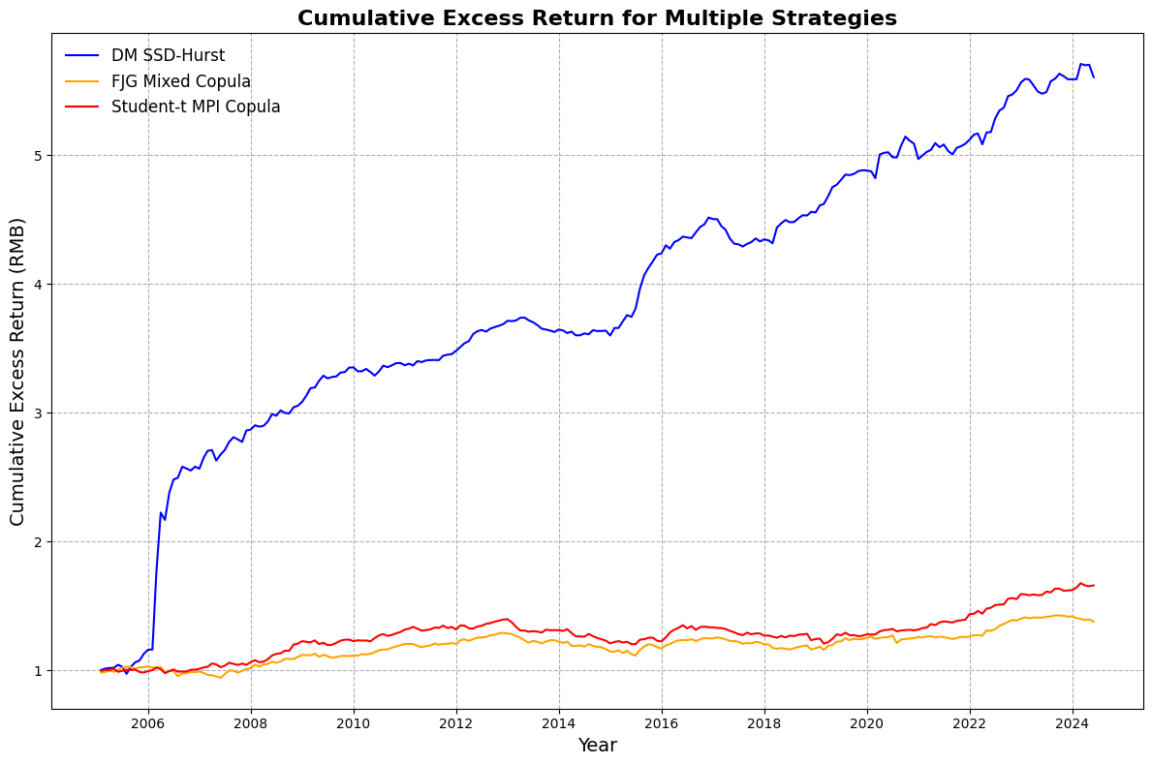**Figure 1.** Cumulative excess return for different methods.

Note: This figure illustrates the growth of wealth, starting from an initial investment of 1 RMB in each strategy. The cumulative excess returns are calculated based on the returns on employed capital, with transaction costs taken into account.

Figure 2 presents the rolling 3-year Sharpe ratio for the same three strategies, providing insight into their risk-adjusted performance over time. The DM SSD-Hurst strategy again maintains superior performance, with its Sharpe ratio consistently higher than the other two strategies, particularly from 2009 to 2016. However, the performance gap narrows after 2020, with the student-t MPI Copula strategy showing notable improvement in its Sharpe ratio, even approaching the DM SSD-Hurst strategy around 2022. The FJG Mixed Copula strategy, while consistently lower in terms of Sharpe ratio, exhibits a gradual upward trend toward the end of the period. Overall, while the DM SSD-Hurst strategy leads in both cumulative return and risk-adjusted performance, the gap between the strategies, particularly in risk-adjusted terms, becomes less pronounced in the later years.

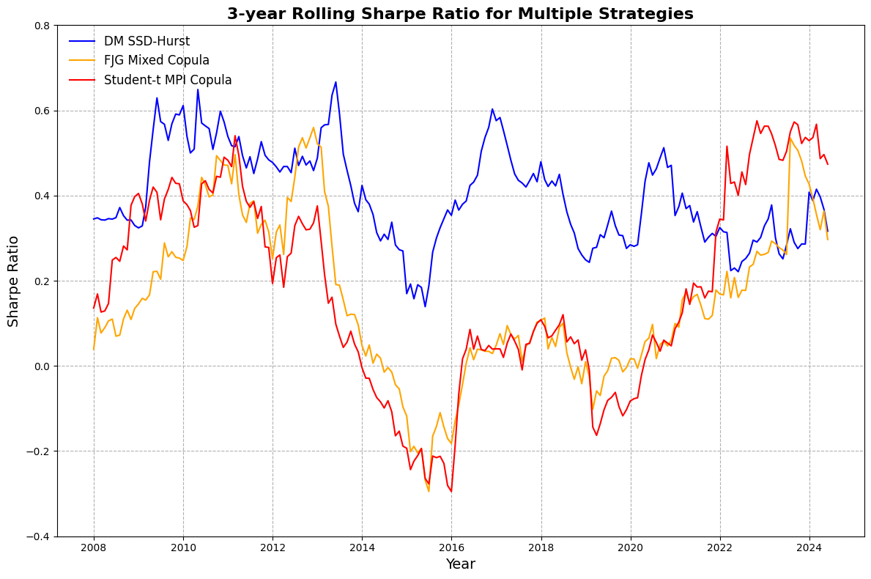

**Figure 2.** Rolling Sharpe Ratio over a 3-year period.

Note: This figure presents the rolling Sharpe ratio calculated over a 3-year (36-month) window for three distinct pairs trading strategies.

Figure 3 displays the distribution of trade returns after accounting for transaction costs for each strategy. All strategies show a noticeable leftward skew, indicating that extreme negative returns are more common than extreme positive returns. This is largely due to the fact that trades are generally closed when they converge based on predefined criteria. However, trades that do not converge remain open throughout the trading period, leading to the potential accumulation of losses. In rare cases, higher profits can occur when a pair’s price spread unexpectedly diverges by more than the threshold required to trigger the trade. A similar dynamic can occur when a pair converges, yielding larger-than-expected profits. Conversely, non-converging trades can result in significant losses before being forcibly closed by the strategy at the end of the trading period, contributing to the fat left tails seen in the distributions.

For strategies like the DM and cointegration methods, where trade entry and exit decisions are directly based on stock price movements, the scale of profit per trade is largely determined by the degree of divergence used to open the position. As a result, the potential for large gains is constrained, and the right tails of the distributions are relatively thin.

In contrast, the copula method, where trade entry and exit are based on the probability of relative mispricing between pairs rather than absolute price levels, shows a broader potential for positive returns, which can explain the slightly fatter right tail in its distribution. In practice, the application of a stop-loss mechanism could help mitigate extreme losses, giving copula-based strategies the potential to perform well without being capped by a fixed threshold for profitability. This flexibility allows for higher gains when the strategy is correct, although it also exposes the strategy to greater risks.

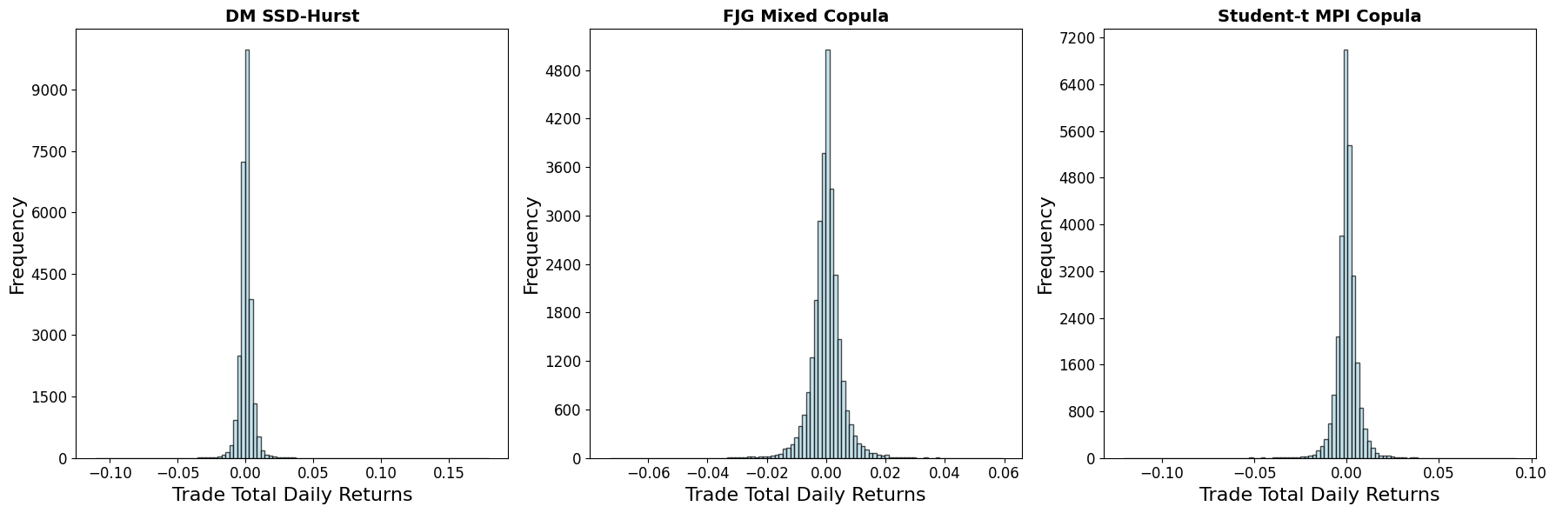

**Figure 3.** Distribution of trade total daily returns of 20 pairs.

Note: This figure displays the distribution of trade total daily returns after accounting for transaction costs across three different strategies. Each strategy represents a different methodology applied to 20 pairs, showing how frequently various return levels occurred. The three strategies depicted are DM SSD-Hurst, FJG Mixed Copula, and Student-t MPI Copula, with returns concentrated around 0, indicating minimal deviation in daily returns.

## 5.2 Risk Adjusted Performance

As the return series of the pairs trading strategies are not normally distributed, relying solely on the Sharpe ratio may underestimate risk and overestimate performance (Eling, 2008). To address this, we further analyze the risk profiles of the strategies using downside performance measures and drawdown metrics. Table 5 presents various risk-adjusted performance measures for each strategy before and after transaction costs.

Lower partial moment measures focus on the negative deviations of returns from a specified threshold, providing a more accurate assessment of downside risk compared to the Sharpe ratio, which treats positive and negative deviations equally. The Omega ratio is defined as the ratio of returns above a threshold to returns below that threshold. The Sortino ratio measures the average excess return relative to the downside deviation (the square root of the second lower partial moment). The Kappa 3 ratio extends this concept to the third lower partial moment, accounting for the skewness of the return distribution.

Drawdown measures assess the magnitude and duration of portfolio losses over time. Maximum drawdown represents the largest peak-to-trough decline during the period. The Calmar ratio is the ratio of the average annualized excess return to the maximum drawdown, indicating return per unit of drawdown risk. The Sterling ratio refines this by considering the average of the most significant continuous drawdowns, reducing sensitivity to outliers. The Burke ratio further adjusts for risk by using the square root of the sum of squared drawdowns in the denominator.

Examining the lower partial moment measures before transaction costs, the SSD-Hurst strategy exhibits the highest Omega ratio of 5.0290, indicating a strong proportion of gains over losses above the threshold return. It also has the highest Sortino ratio (0.7395) and Kappa 3 (0.6951), suggesting superior performance when considering downside risk and skewness. The SSD-NZC strategy follows, with an Omega ratio of 3.4930, but noticeably lower than SSD-Hurst, highlighting the latter's dominance in managing downside risk.

Among the copula-based strategies, the Gaussian and FJG copulas perform relatively well. Their Sortino ratios and Kappa 3 values are also higher compared to other copula strategies, indicating better risk-adjusted returns when accounting for downside deviations and skewness. In contrast, the Clayton and Gumbel copulas show the lowest Omega ratios among the copula strategies, along with lower Sortino and Kappa 3 ratios. This suggests that these strategies are less effective in generating returns that compensate for the downside risk taken.

Regarding the drawdown measures before transaction costs, the SSD-Hurst strategy again outperforms others with a maximum drawdown of -0.0831, which is moderate compared to other strategies. Its Calmar ratio of 1.2767 is the highest, indicating that it provides the best return per unit of drawdown risk. The Sterling ratio and Burke ratio are also significantly higher for SSD-Hurst, reinforcing its superior performance in managing drawdowns. The student-t copula strategy stands out among copula methods with the lowest maximum drawdown of -0.0730 and a relatively high Calmar ratio of 0.4637. This indicates that the student-t copula is effective in limiting losses during adverse periods, possibly due to its ability to capture tail dependencies in asset pairs.

After accounting for transaction costs, all strategies experience a decline in performance metrics. The Omega ratios decrease across the board, with the SSD-Hurst strategy's Omega ratio reducing from 5.0290 to 4.7299—a relatively small decline, suggesting resilience to transaction costs. Its Sortino ratio actually increases slightly to 0.7982, which may be attributed to a reduction in downside deviation outweighing the decrease in mean return. The copula strategies see more pronounced declines. For example, the Clayton copula's Omega ratio drops from 1.5983 to 1.2642, and its Sortino ratio falls by approximately 49%. The Gumbel copula's performance diminishes significantly, with its Omega ratio decreasing to 1.1852 and Sortino ratio to 0.0603, indicating that transaction costs have a substantial negative impact on its risk-adjusted performance.

Despite the overall decline, the SSD-Hurst strategy maintains the highest Calmar ratio after transaction costs at 1.4971, even improving from its before-cost value. This suggests that its annualized excess return remains strong relative to the maximum drawdown experienced, highlighting its robustness. The student-t copula continues to perform relatively well among copula strategies after transaction costs, with an Omega ratio of 1.5929 and a Sortino ratio of 0.1805. Its Calmar ratio decreases slightly to 0.1982, but it still maintains a favorable drawdown profile compared to other copula methods. The substantial reductions in the Sterling and Burke ratios across all strategies indicate that transaction costs significantly affect the ability of the strategies to generate excess returns relative to their drawdowns. The SSD-Hurst strategy's Sterling ratio decreases from 7.1608 to 6.2675, while the copula strategies experience sharper declines, with some Sterling ratios falling below 0.3.

Transaction costs have a noticeable impact on the risk-adjusted performance of the pairs trading strategies. The SSD strategies, particularly SSD-Hurst, show resilience, with only modest declines in performance measures. This may be due to their higher average returns and possibly lower trading frequency, resulting in reduced cumulative transaction costs. Copula-based strategies, however, are more adversely affected. The strategies with lower before-cost returns, such as the Clayton and Gumbel copulas, become even less attractive after accounting for transaction costs. The increased sensitivity can be attributed to the higher turnover rates or smaller profit margins per trade, where transaction costs erode a significant portion of the gains.

The differences in risk-adjusted performance among the copula strategies can be linked to the dependence structures each copula captures. The Gaussian copula assumes normal dependence and captures linear correlations between asset pairs. Its relatively stable performance suggests that linear relationships are somewhat effective but may not fully capture the complexities of financial markets. The student-t copula models both linear correlations and tail dependencies. Its superior drawdown metrics indicate that accounting for extreme co-movements enhances the strategy's ability to mitigate losses during market stress. The Clayton and Gumbel copulas focus on lower and upper tail dependencies, respectively. Their poorer performance implies that the types of tail dependencies they capture are less prevalent or profitable in the dataset used. This may result in less effective identification of trading opportunities and increased vulnerability to transaction costs. The Frank copula, which does not exhibit tail dependence, performs moderately. Its inability to model extreme co-movements may limit its effectiveness in managing downside risk, leading to higher drawdowns and lower risk-adjusted returns.

The SSD-Hurst method's consistent outperformance can be attributed to its ability to effectively select pairs based on statistical similarities and mean-reversion properties, leading to more profitable trades and better risk management. Its robustness against transaction costs highlights the strength of its underlying strategy.

The risk-adjusted performance analysis reveals that the SSD-Hurst strategy outperforms both the SSD-NZC and copula-based strategies across most metrics, both before and after transaction costs. Its superior management of downside risk and drawdowns makes it an attractive strategy for pairs trading. Among the copula strategies, the student-t copula demonstrates relatively better performance, suggesting that modeling tail dependencies is beneficial for capturing profitable trading opportunities and managing risk. However, transaction costs significantly impact the copula strategies, underscoring the importance of considering trading frictions in strategy evaluation. The findings highlight that while advanced dependence modeling via copulas offers theoretical advantages, practical implementation requires careful consideration of transaction costs and the specific dependence structures present in the data. Strategies that align closely with the actual market dynamics and effectively manage downside risk are more likely to achieve superior risk-adjusted performance.

**Table 5.** Overview of Risk-Adjusted Performance.

|  |  |  |  |  |  |  |  |
| --- | --- | --- | --- | --- | --- | --- | --- |
|  | Lower partial moments measures | | | Drawdown measures | | | |
|  | Omega | Sortino ratio | Kappa 3 | Max Drawdown | Calmar ratio | Sterling ratio | Burke ratio |
| *Panel A: Before transaction costs* | | | | | | | |
| SSD-Hurst | 5.0290 | 0.7395 | 0.6951 | -0.0831 | 1.2767 | 7.1608 | 0.4977 |
| SSD-NZC | 3.4930 | 0.4769 | 0.4428 | -0.0963 | 1.0745 | 4.1353 | 0.2782 |
| Clayton | 1.5983 | 0.1558 | 0.1637 | -0.1005 | 0.2870 | 0.9600 | 0.0577 |
| Frank | 1.7884 | 0.2171 | 0.2312 | -0.0988 | 0.3258 | 1.1411 | 0.0704 |
| Gaussian | 1.8122 | 0.2307 | 0.2610 | -0.1014 | 0.3590 | 1.0808 | 0.0685 |
| Gumbel | 1.5314 | 0.1558 | 0.1688 | -0.1208 | 0.2135 | 0.7163 | 0.0440 |
| Student-t | 1.6723 | 0.1762 | 0.1900 | -0.0730 | 0.4637 | 1.4738 | 0.0917 |
| Optimal | 1.5375 | 0.1444 | 0.1509 | -0.1197 | 0.1901 | 0.5929 | 0.0374 |
| CFG | 1.5689 | 0.1635 | 0.1816 | -0.0953 | 0.2497 | 0.6288 | 0.0393 |
| CJF | 1.6587 | 0.1738 | 0.1891 | -0.1171 | 0.2424 | 0.7158 | 0.0460 |
| CJG | 1.6131 | 0.1699 | 0.1906 | -0.1258 | 0.2217 | 0.9192 | 0.0546 |
| FJG | 1.7169 | 0.2053 | 0.2150 | -0.1112 | 0.2765 | 1.0946 | 0.0656 |
| *Panel B: After transaction costs* | | | | | | | |
| SSD-Hurst | 4.7299 | 0.7982 | 0.7966 | -0.0675 | 1.4971 | 6.2675 | 0.4372 |
| SSD-NZC | 3.2149 | 0.4462 | 0.4099 | -0.0973 | 0.9916 | 3.6369 | 0.2368 |
| Clayton | 1.2642 | 0.0795 | 0.0794 | -0.1326 | 0.1045 | 0.2431 | 0.0145 |
| Frank | 1.4204 | 0.1282 | 0.1334 | -0.1284 | 0.1470 | 0.5225 | 0.0306 |
| Gaussian | 1.4832 | 0.1495 | 0.1670 | -0.1516 | 0.1542 | 0.4257 | 0.0247 |
| Gumbel | 1.1852 | 0.0603 | 0.0639 | -0.1960 | 0.0506 | 0.1553 | 0.0086 |
| Student-t | 1.5929 | 0.1805 | 0.2079 | -0.1382 | 0.1982 | 0.5405 | 0.0319 |
| Optimal | 1.2470 | 0.0759 | 0.0766 | -0.1379 | 0.0822 | 0.2501 | 0.0141 |
| CFG | 1.2379 | 0.0739 | 0.0806 | -0.1320 | 0.0818 | 0.1961 | 0.0113 |
| CJF | 1.3254 | 0.0956 | 0.1016 | -0.1439 | 0.1068 | 0.2917 | 0.0173 |
| CJG | 1.2967 | 0.0901 | 0.0999 | -0.1788 | 0.0818 | 0.2418 | 0.0143 |
| FJG | 1.3761 | 0.1174 | 0.1210 | -0.1362 | 0.1288 | 0.4162 | 0.0245 |

Notes: This table provides an overview of key risk-adjusted performance measures for the monthlyemployed capital excess returns of various pairs trading strategies, including SSD-Hurst, SSD-NZC, and several copula-based strategies. Panel A shows the results before transaction costs, while Panel B presents the results after transaction costs. The performance metrics include lower partial moments (Omega ratio, Sortino ratio, Kappa 3) and drawdown measures (Max Drawdown, Calmar ratio, Sterling ratio, Burke ratio).

## 5.3 Risk Characteristics of Pairs Trading Strategies

To further understand the economic drivers behind our findings and to assess whether the profitability of pairs trading is a compensation for risk, we perform a regression of daily excess returns on various risk factors. Specifically, we use Fama & French’s (2015) five-factor model, which includes the excess return on a broad market portfolio (Rm − Rf), the difference between the return on small-cap stocks and large-cap stocks (SMB), the difference between the return on high book-to-market stocks and low book-to-market stocks (HML), the difference in returns between the most profitable and least profitable stocks (RMW), and the difference in returns between conservatively investing firms and aggressively investing firms (CMA). In addition, we include the momentum (Mom) and long-term reversal (REV) factors.

The model is structured as follows:

(5.1)

where denotes the portfolio, and represents time. The error terms are assumed to have a mean of zero and are uncorrelated over time. Heteroscedasticity and autocorrelation adjustments are made using the Newey-West method, with a lag length of six.

The regression results presented in Table 6 provide insights into whether the profits from the pairs trading strategies can be explained by common risk factors or represent abnormal returns. In Panel A (before transaction costs), the SSD-Hurst and SSD-NZC strategies exhibit positive alphas of 0.0052 and 0.0055, respectively. These alphas suggest that, on average, these strategies generate monthly excess returns of approximately 0.52% and 0.55% that are not explained by the included risk factors, indicating strong risk-adjusted performance. Among the copula-based strategies, the alphas are generally smaller and less significant. For instance, the Clayton strategy shows a negative alpha of -0.0006 before costs, suggesting that its returns are largely explained by the risk factors or that it may not generate significant abnormal returns.

The coefficients on the MKT factor are close to zero or negative for most strategies, indicating minimal exposure to market risk. This aligns with the market-neutral nature of pairs trading strategies, which typically involve taking offsetting long and short positions to eliminate the influence of market movements. The SMB factor coefficients are positive for all strategies and statistically significant for some. For example, the Clayton strategy has a significant SMB coefficient of 0.2059** before costs and 0.1993** after costs, suggesting a bias toward small-cap stocks. This may be because smaller companies present more mispricing opportunities due to lower analyst coverage and liquidity. The HML factor coefficients are positive across all strategies but not statistically significant, indicating a mild exposure to value stocks but not a strong determinant of returns.

Regarding the RMW factor, the coefficients are positive but generally insignificant, indicating that the strategies do not have substantial exposure to firms with varying profitability levels. The CMA factor shows negative coefficients for all strategies, with the SSD-NZC strategy exhibiting a significant negative coefficient (-0.2967* before costs and -0.2973* after costs). A negative CMA coefficient implies that the strategies are tilted toward firms with aggressive investment policies, potentially capitalizing on inefficiencies associated with such firms. The MOM factor coefficients are mostly negative but insignificant, indicating that the strategies may benefit slightly from contrarian positions against momentum stocks, which is consistent with the mean-reversion nature of pairs trading. The REV factor coefficients are small and not statistically significant, suggesting that long-term reversal effects do not play a significant role in the strategies' returns.

In Panel B (after transaction costs), the alphas for the SSD-Hurst and SSD-NZC strategies remain positive at 0.0048 and 0.0049, respectively, though slightly reduced due to trading costs. This persistence indicates that these strategies continue to generate abnormal returns even after accounting for transaction costs. The copula-based strategies’ alphas become more negative or remain small after costs, highlighting the sensitivity of these strategies to transaction costs and potentially lower profitability.

Transaction costs have a noticeable impact on the profitability of the strategies, particularly for those with lower alphas or higher turnover rates. The SSD-Hurst and SSD-NZC strategies maintain positive alphas after costs, suggesting that their trading frequency and associated costs do not significantly erode their abnormal returns. In contrast, some copula-based strategies experience a reduction in alpha, indicating that transaction costs may outweigh the gains from these strategies.

The positive and significant SMB coefficients for some strategies indicate an exposure to small-cap stocks, which may contribute to their returns. This exposure could arise from the selection of stock pairs involving smaller firms or from exploiting inefficiencies prevalent in the small-cap segment. The negative CMA coefficients suggest a tendency to invest in firms with aggressive investment practices. These firms might offer more opportunities for mispricing due to their growth-oriented strategies and potentially higher volatility. The minimal exposure to the MKT factor across strategies confirms their market-neutral stance, making them attractive for diversification purposes in a portfolio context.

The regression analysis reveals that the profitability of the SSD-Hurst and SSD-NZC pairs trading strategies cannot be fully explained by common risk factors, as evidenced by their significant positive alphas before and after transaction costs. These strategies appear to capture unique sources of return, possibly linked to market inefficiencies or behavioral biases not accounted for by traditional risk factors. For the copula-based strategies, the results are mixed. While some show positive alphas before costs, these gains are often offset by transaction costs, reducing their effectiveness. The significant exposure to the SMB factor in certain copula strategies indicates that returns may be partially driven by size-related risks rather than pure arbitrage opportunities. Overall, the findings suggest that pairs trading strategies, particularly those based on stochastic dominance (SSD-Hurst and SSD-NZC), offer risk-adjusted returns that are not solely compensation for bearing systematic risk. Investors may consider these strategies to enhance portfolio performance, but they should remain mindful of transaction costs and the specific risk exposures associated with each strategy.

By analyzing the regression results, we gain a deeper understanding of the risk characteristics and potential sources of profitability for different pairs trading strategies. The significant alphas, especially for the SSD-based strategies, underscore the potential for these strategies to deliver abnormal returns beyond what is explained by conventional risk factors.

**Table 6.** Monthly risk profile based on Fama and French five factors plus Momentum and Long-Term Reversal.

|  |  |  |  |  |  |  |  |  |
| --- | --- | --- | --- | --- | --- | --- | --- | --- |
| Strategy | Alpha | MKT | SMB | HML | RMW | CMA | MOM | REV |
| *Panel A: Before transaction costs* | | | | | | | | |
| SSD-Hurst | 0.0052 | 0.0049 | 0.1828 | 0.1314 | 0.0465 | -0.2632 | -0.0729 | -0.0486 |
| SSD-NZC | 0.0055 | 0.0028 | 0.1851 | 0.1573 | 0.0729 | -0.2967* | -0.0663 | -0.0251 |
| Clayton | -0.0006 | -0.0041 | 0.2059** | 0.1080 | 0.1016 | -0.1966* | 0.0042 | 0.0126 |
| Frank | 0.0011 | -0.0202 | 0.1178 | 0.0438 | 0.1051 | -0.0702 | -0.0127 | 0.0244 |
| Gaussian | 0.0011 | -0.0078 | 0.1126 | 0.0917 | 0.0538 | -0.1167 | 0.0284 | 0.0231 |
| Gumbel | 0.0001 | -0.0097 | 0.1345 | 0.0674 | 0.1057 | -0.1160 | 0.0024 | 0.0147 |
| Student-t | 0.0009 | 0.0075 | 0.0691 | 0.0280 | 0.0359 | -0.1030 | -0.0243 | 0.0093 |
| Optimal | -0.0003 | -0.0156 | 0.1721* | 0.0945 | 0.0981 | -0.1220 | 0.0065 | 0.0233 |
| CFG | 0.0001 | -0.0088 | 0.1418 | 0.0080 | 0.0812 | -0.0861 | -0.0010 | 0.0278 |
| CJF | 0.0001 | -0.0036 | 0.1585 | 0.0662 | 0.1182 | -0.1029 | -0.0119 | 0.0188 |
| CJG | 0.0000 | -0.0092 | 0.1815* | 0.0761 | 0.0963 | -0.0951 | 0.0037 | 0.0205 |
| FJG | 0.0005 | -0.0199 | 0.1506 | 0.0436 | 0.1096 | -0.1086 | -0.0045 | 0.0257 |
| *Panel B: After transaction costs* | | | | | | | | |
| SSD-Hurst | 0.0048 | 0.0046 | 0.1811 | 0.1314 | 0.0457 | -0.2652 | -0.0705 | -0.0476 |
| SSD-NZC | 0.0049 | 0.0025 | 0.1865 | 0.1577 | 0.0725 | -0.2973* | -0.0653 | -0.0238 |
| Clayton | -0.0018 | -0.0028 | 0.1993** | 0.0998 | 0.0988 | -0.1881* | 0.0053 | 0.0133 |
| Frank | 0.0000 | -0.0182 | 0.1181 | 0.0421 | 0.1044 | -0.0717 | -0.0125 | 0.0245 |
| Gaussian | 0.0000 | -0.0075 | 0.1123 | 0.0915 | 0.0507 | -0.1207 | 0.0257 | 0.0236 |
| Gumbel | -0.0013 | -0.0097 | 0.1366 | 0.0704 | 0.1010 | -0.1240 | 0.0028 | 0.0142 |
| Student-t | 0.0004 | -0.0129 | 0.1234 | 0.0458 | 0.0954 | -0.0782 | 0.0055 | 0.0263 |
| Optimal | -0.0013 | -0.0119 | 0.1682* | 0.0891 | 0.0964 | -0.1173 | 0.0042 | 0.0241 |
| CFG | -0.0010 | -0.0077 | 0.1446 | 0.0094 | 0.0831 | -0.0883 | -0.0003 | 0.0275 |
| CJF | -0.0010 | -0.0026 | 0.1602* | 0.0651 | 0.1178 | -0.1043 | -0.0133 | 0.0178 |
| CJG | -0.0011 | -0.0064 | 0.1825* | 0.0783 | 0.0943 | -0.1011 | 0.0041 | 0.0204 |
| FJG | -0.0006 | -0.0186 | 0.1516 | 0.0414 | 0.1123 | -0.1076 | -0.0045 | 0.0256 |

Notes: This table presents the results of regressing the monthly returns of various pairs trading strategies on the Fama-French five-factor model augmented with Momentum and Long-Term Reversal factors. Panel A reports the regression coefficients before accounting for transaction costs, while Panel B reports the coefficients after transaction costs. The column labeled 'Alpha' represents the estimated regression intercept, indicating the strategy's average abnormal return not explained by the included factors. The columns 'MKT', 'SMB', 'HML', 'RMW', 'CMA', 'MOM', and 'REV' report the estimated coefficients for the following factors, respectively: MKT: Market Excess Return (Market Risk Premium), SMB: Small Minus Big (size factor), HML: High Minus Low (value factor), RMW: Robust Minus Weak (profitability factor), CMA: Conservative Minus Aggressive (investment factor), MOM: Momentum factor, REV: Long-Term Reversal factor.

* significant at the 10% level.

** significant at the 5% level.

*** significant at the 1% level.

## 5.4 Robustness and Sensitivity Analysis

### 5.4.1 Varying Opening Thresholds

In our previous analyses, we applied a constant opening threshold of 0.6 for the copula-based trading strategies. To evaluate the robustness of these strategies and understand how different opening thresholds affect their performance, we conducted a sensitivity analysis by varying the opening thresholds from 0.2 to 0.8 in increments of 0.1. Table 7 presents the summary statistics for the monthly returns on committed capital after accounting for trading costs across various opening thresholds for each copula-based strategy.

The sensitivity analysis reveals that the performance of the copula-based strategies is generally robust to changes in the opening threshold. For most strategies, the mean monthly return on committed capital after transaction costs remains relatively stable across different thresholds. For example, the Gaussian copula strategy maintains a mean return ranging from 0.0015 to 0.0016 as the opening threshold varies from 0.2 to 0.8. Similarly, the Student-t copula strategy exhibits mean returns between 0.0015 and 0.0020 across the same threshold range.

As the opening threshold increases, we observe a slight decrease in the standard deviation of returns for all strategies. This suggests that higher opening thresholds may lead to more consistent returns due to a reduction in the number of trades with extreme outcomes. For instance, the standard deviation for the Gaussian copula strategy decreases from 0.0093 at a threshold of 0.2 to 0.0065 at a threshold of 0.8.

The minimum returns tend to become less negative with higher opening thresholds, indicating a potential reduction in downside risk. Conversely, the maximum returns also decrease slightly, which may reflect fewer opportunities for large gains when the strategy is more selective in opening positions. This trade-off between risk and return aligns with the expectation that requiring a larger divergence to initiate a trade result in fewer but potentially higher-quality trading opportunities.

Overall, the copula-based strategies demonstrate resilience to varying opening thresholds, maintaining consistent performance metrics. This robustness suggests that the strategies are not overly sensitive to the specific threshold value used, allowing investors flexibility in selecting a threshold that aligns with their risk tolerance and investment objectives. Figure 6 shows that cumulative excess return of the copula method is robust to different opening thresholds.

These findings highlight the importance of calibrating the opening threshold in pairs trading strategies. While lower thresholds may increase the frequency of trades and potential returns, they may also introduce greater volatility and risk. Higher thresholds can mitigate risk by filtering out less promising trades but may also limit return potential due to fewer trading opportunities.

In conclusion, the sensitivity analysis supports the robustness of the copula-based pairs trading strategies across a range of opening thresholds. Investors can adjust the opening threshold to strike an appropriate balance between return and risk, tailoring the strategy to their specific preferences without significantly compromising performance.

**Table 7.** Copula Method’s Sensitivity Analysis with Various Opening Threshold for Committed Capital Return After Trading Costs.

|  |  |  |  |  |  |  |  |  |
| --- | --- | --- | --- | --- | --- | --- | --- | --- |
| Strategy | Opening Threshold | 0.2 | 0.3 | 0.4 | 0.5 | 0.6 | 0.7 | 0.8 |
| Clayton | Mean | 0.0001 | 0.0003 | 0.0003 | 0.0005 | 0.0007 | 0.0008 | 0.0007 |
|  | Min | -0.0415 | -0.0401 | -0.0360 | -0.0339 | -0.0323 | -0.0351 | -0.0323 |
|  | Max | 0.0240 | 0.0304 | 0.0261 | 0.0199 | 0.0239 | 0.0231 | 0.0242 |
|  | Std. Dev. | 0.0088 | 0.0087 | 0.0080 | 0.0072 | 0.0069 | 0.0067 | 0.0062 |
| Frank | Mean | 0.0014 | 0.0015 | 0.0015 | 0.0013 | 0.0012 | 0.0013 | 0.0011 |
|  | Min | -0.0491 | -0.0427 | -0.0442 | -0.0378 | -0.0355 | -0.0331 | -0.0348 |
|  | Max | 0.0214 | 0.0258 | 0.0203 | 0.0178 | 0.0154 | 0.0167 | 0.0165 |
|  | Std. Dev. | 0.0085 | 0.0084 | 0.0080 | 0.0071 | 0.0069 | 0.0067 | 0.0063 |
| Gaussian | Mean | 0.0016 | 0.0016 | 0.0016 | 0.0015 | 0.0015 | 0.0015 | 0.0015 |
|  | Min | -0.0384 | -0.0344 | -0.0336 | -0.0323 | -0.0276 | -0.0270 | -0.0248 |
|  | Max | 0.0363 | 0.0334 | 0.0320 | 0.0307 | 0.0244 | 0.0235 | 0.0223 |
|  | Std. Dev. | 0.0093 | 0.0087 | 0.0082 | 0.0078 | 0.0072 | 0.0069 | 0.0065 |
| Gumbel | Mean | 0.0004 | 0.0007 | 0.0007 | 0.0007 | 0.0008 | 0.0007 | 0.0006 |
|  | Min | -0.0433 | -0.0432 | -0.0404 | -0.0342 | -0.0305 | -0.0302 | -0.0266 |
|  | Max | 0.0249 | 0.0364 | 0.0326 | 0.0295 | 0.0269 | 0.0211 | 0.0150 |
|  | Std. Dev. | 0.0090 | 0.0089 | 0.0085 | 0.0074 | 0.0072 | 0.0068 | 0.0063 |
| Student-t | Mean | 0.0020 | 0.0020 | 0.0017 | 0.0017 | 0.0016 | 0.0015 | 0.0016 |
|  | Min | -0.0304 | -0.0296 | -0.0279 | -0.0283 | -0.0248 | -0.0252 | -0.0257 |
|  | Max | 0.0301 | 0.0325 | 0.0268 | 0.0249 | 0.0294 | 0.0302 | 0.0261 |
|  | Std. Dev. | 0.0087 | 0.0084 | 0.0080 | 0.0073 | 0.0070 | 0.0067 | 0.0063 |
| Optimal | Mean | 0.0012 | 0.0010 | 0.0009 | 0.0008 | 0.0008 | 0.0007 | 0.0005 |
|  | Min | -0.0490 | -0.0431 | -0.0458 | -0.0379 | -0.0368 | -0.0336 | -0.0367 |
|  | Max | 0.0212 | 0.0195 | 0.0182 | 0.0177 | 0.0133 | 0.0163 | 0.0133 |
|  | Std. Dev. | 0.0080 | 0.0077 | 0.0074 | 0.0066 | 0.0063 | 0.0059 | 0.0056 |
| CFG | Mean | 0.0009 | 0.0010 | 0.0008 | 0.0009 | 0.0008 | 0.0009 | 0.0007 |
|  | Min | -0.0422 | -0.0371 | -0.0376 | -0.0320 | -0.0297 | -0.0258 | -0.0273 |
|  | Max | 0.0267 | 0.0233 | 0.0212 | 0.0222 | 0.0201 | 0.0166 | 0.0152 |
|  | Std. Dev. | 0.0087 | 0.0083 | 0.0078 | 0.0070 | 0.0067 | 0.0062 | 0.0058 |
| CJF | Mean | 0.0012 | 0.0011 | 0.0010 | 0.0011 | 0.0011 | 0.0011 | 0.0010 |
|  | Min | -0.0407 | -0.0352 | -0.0291 | -0.0278 | -0.0260 | -0.0262 | -0.0269 |
|  | Max | 0.0281 | 0.0234 | 0.0221 | 0.0220 | 0.0216 | 0.0203 | 0.0174 |
|  | Std. Dev. | 0.0086 | 0.0082 | 0.0076 | 0.0072 | 0.0068 | 0.0063 | 0.0058 |
| CJG | Mean | 0.0014 | 0.0013 | 0.0012 | 0.0010 | 0.0009 | 0.0008 | 0.0008 |
|  | Min | -0.0364 | -0.0327 | -0.0264 | -0.0236 | -0.0233 | -0.0239 | -0.0251 |
|  | Max | 0.0247 | 0.0237 | 0.0201 | 0.0236 | 0.0247 | 0.0173 | 0.0166 |
|  | Std. Dev. | 0.0086 | 0.0084 | 0.0078 | 0.0071 | 0.0066 | 0.0060 | 0.0057 |
| FJG | Mean | 0.0014 | 0.0016 | 0.0015 | 0.0014 | 0.0013 | 0.0014 | 0.0012 |
|  | Min | -0.0468 | -0.0409 | -0.0425 | -0.0362 | -0.0313 | -0.0296 | -0.0304 |
|  | Max | 0.0274 | 0.0252 | 0.0243 | 0.0231 | 0.0198 | 0.0194 | 0.0167 |
|  | Std. Dev. | 0.0092 | 0.0089 | 0.0085 | 0.0079 | 0.0073 | 0.0067 | 0.0062 |

Note: This table provides summary statistics for the sensitivity of monthly returns on committed capital for the copula-based trading strategies after accounting for trading costs. The sensitivity analysis is conducted across various opening thresholds, evaluating performance metrics such as the mean, minimum, maximum, and standard deviation of returns for each threshold. The table highlights how different copula models perform under varying thresholds, offering insights into their risk and return profiles.

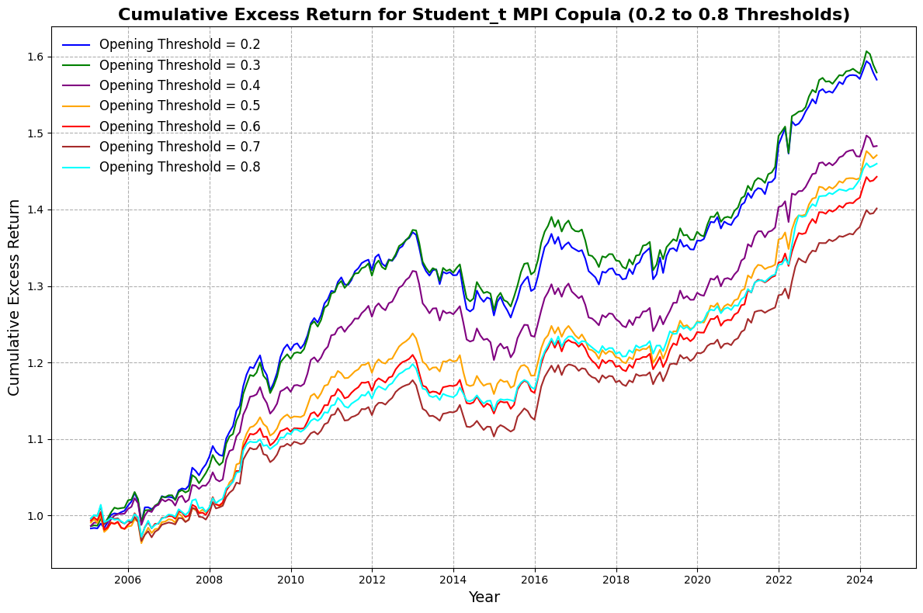

**Figure 4.** Copula method’s cumulative excess return for different opening thresholds.

Notes: This figure shows the evolution of wealth based upon an investment of 1 RMB for the student t copula method using seven different opening thresholds. Return on committed capital after transaction costs is applied to calculate the cumulative excess return.

### 5.4.2 Varying Number of Pairs Traded

In addition to analyzing the impact of different opening thresholds, it is essential to assess how varying the number of pairs traded affects the performance of copula-based pairs trading strategies. This sensitivity analysis provides insights into the scalability of the strategies and their robustness when applied to portfolios of different sizes. Table 8 presents the summary statistics for the monthly returns on committed capital after accounting for trading costs across various numbers of traded pairs, ranging from 5 to 50 pairs.

In analyzing the mean returns of copula-based pairs trading strategies, a general trend emerges: for most copula models, the mean monthly returns on committed capital tend to increase as the number of pairs traded rises from 5 to 50 pairs. This pattern suggests that diversifying across a larger number of pairs can enhance the overall return. Specifically, the Gaussian copula strategy exhibits a consistent increase in mean returns, from 0.0011 with 5 pairs to 0.0025 with 50 pairs. This doubling of mean returns indicates that the Gaussian copula benefits significantly from trading a larger portfolio. Similarly, the Student-t copula strategy's mean return increases from 0.0012 to 0.0023 as the number of pairs increases, highlighting its scalability and the potential for higher profits with more pairs. The Clayton and Frank copulas also show an upward trend in mean returns, although the increases are more modest compared to the Gaussian and Student-t copulas. For example, the Clayton copula's mean return rises from 0.0008 to 0.0012.

Regarding risk and volatility, the standard deviation of returns generally increases with the number of pairs traded. For instance, the Gaussian copula's standard deviation rises from 0.0027 with 5 pairs to 0.0139 with 50 pairs. This increase reflects greater variability in returns due to the inclusion of more assets and potentially more diverse market movements. The minimum monthly returns become more negative as the number of pairs increases. This trend suggests that while the strategies may capture higher returns, they are also exposed to larger potential losses. For example, the student-t copula's minimum return declines from -0.0075 with 5 pairs to -0.0597 with 50 pairs. Conversely, the maximum monthly returns increase with more pairs traded. The Gaussian copula's maximum return grows from 0.0092 to 0.0448, indicating that scaling up the strategy enhances the potential for substantial gains.

The impact of portfolio diversification is evident in these findings. Trading a larger number of pairs can diversify idiosyncratic risks associated with individual pairs. However, the increased exposure to systematic risk factors can amplify overall portfolio volatility, as reflected in the higher standard deviations. The increase in mean returns suggests that the strategies are able to exploit more trading opportunities when more pairs are included. This diversification allows for capturing profits from a broader set of mean-reversion behaviors across different assets.

Copula-specific observations further illuminate these dynamics. The Gaussian and Student-t copulas benefit the most from increasing the number of pairs traded. Their ability to model dependencies effectively across a wide range of assets contributes to enhanced performance at larger portfolio sizes. In contrast, strategies based on the CFG, CJF, CJG, and FJG copulas show relatively stable mean returns regardless of the number of pairs traded, with slight increases at higher pair counts. The standard deviations for these models do not escalate as sharply as those of the Gaussian and Student-t copulas, indicating more controlled volatility, as shown in Figure 5 and 6.

There is a clear trade-off between return and risk. While mean returns increase with more pairs, the accompanying rise in volatility necessitates evaluating the risk-adjusted performance. Investors should consider whether the incremental returns adequately compensate for the additional risk. The analysis suggests that there may be an optimal number of pairs where the trade-off between return and risk is most favorable. For some strategies, such as the Clayton copula, the mean return peaks at 30 or 40 pairs before the increase in volatility outweighs the benefits.

A comparison with prior studies reveals that the sensitivity of strategy performance to the number of pairs traded aligns with findings from other research, which indicates that pairs trading strategies can be sensitive to portfolio size. Unlike some prior research where increasing the number of pairs does not consistently enhance performance, our results show that for certain copula-based strategies, especially the Gaussian and Student-t copulas, scaling up the number of pairs can improve mean returns. However, the increased volatility and risk associated with larger portfolios underscore the importance of risk management and careful selection of pairs.

The implications for investors are significant. Scalability is a key advantage, as investors aiming to deploy larger amounts of capital may find copula-based strategies particularly attractive due to their ability to maintain or enhance returns when scaled up. Risk management becomes essential as the number of pairs increases, with robust practices needed to mitigate the heightened volatility and potential for larger drawdowns. Strategy selection is crucial, as the choice of copula model plays a significant role in how performance scales with the number of pairs. Investors should consider the characteristics of each model in relation to their investment objectives and risk tolerance.

Several limitations and considerations should be acknowledged. Market conditions can affect the effectiveness of increasing the number of pairs, as correlations between assets may change during periods of high volatility or market stress, impacting strategies that rely on historical dependencies. Transaction costs may rise with more pairs due to increased trading frequency and portfolio turnover, potentially eroding net returns if not carefully managed. Data quality and selection bias are critical, as including less liquid or more volatile assets may introduce additional risks. Ensuring high-quality data and robust pair selection criteria is essential for reliable performance.

In conclusion, the analysis of varying the number of pairs traded reveals that copula-based pairs trading strategies can benefit from portfolio diversification, with mean returns generally increasing as more pairs are included. However, this comes with the trade-off of increased volatility and potential exposure to larger losses. Investors should balance the desire for higher returns with the associated risks when deciding on the number of pairs to trade. The choice of copula model is also critical, as different models exhibit varying degrees of sensitivity to portfolio size. Strategies based on the Gaussian and Student-t copulas show promising scalability but require diligent risk management. Ultimately, the optimal number of pairs and choice of copula model depend on the investor's objectives, risk appetite, and market outlook. By carefully analyzing these factors, investors can tailor their pairs trading strategies to achieve a favorable balance between return and risk.

Recommendations for future research include investigating the impact of dynamically selecting pairs based on changing market conditions or predictive indicators to enhance performance and manage risk. Employing risk-adjusted performance metrics such as the Sharpe Ratio or Information Ratio can better assess the trade-off between return and volatility across different portfolio sizes. Analyzing how varying the number of pairs affects strategy performance during different market regimes (e.g., bull vs. bear markets) could identify conditions under which scaling up is most advantageous. Incorporating a detailed assessment of transaction costs associated with trading more pairs can provide a clearer picture of net returns and strategy viability.

**Table 8.** Copula Method’s Sensitivity Analysis with Various Pairs Traded for Committed Capital Return After Trading Costs.

|  |  |  |  |  |  |  |  |
| --- | --- | --- | --- | --- | --- | --- | --- |
| Strategy | Number of Pairs | 5 Pairs | 10 Pairs | 20 Pairs | 30 Pairs | 40 Pairs | 50 Pairs |
| Clayton | Mean | 0.0008 | 0.0008 | 0.0007 | 0.0010 | 0.0010 | 0.0012 |
|  | Min | -0.0092 | -0.0195 | -0.0323 | -0.0314 | -0.0481 | -0.0541 |
|  | Max | 0.0082 | 0.0174 | 0.0239 | 0.0275 | 0.0394 | 0.0494 |
|  | Std. Dev. | 0.0024 | 0.0041 | 0.0069 | 0.0085 | 0.0108 | 0.0134 |
| Frank | Mean | 0.0009 | 0.0013 | 0.0012 | 0.0013 | 0.0014 | 0.0017 |
|  | Min | -0.0154 | -0.0263 | -0.0355 | -0.0512 | -0.0555 | -0.0571 |
|  | Max | 0.0093 | 0.0123 | 0.0154 | 0.0248 | 0.0305 | 0.0336 |
|  | Std. Dev. | 0.0027 | 0.0041 | 0.0069 | 0.0094 | 0.0120 | 0.0137 |
| Gaussian | Mean | 0.0011 | 0.0013 | 0.0015 | 0.0015 | 0.0020 | 0.0025 |
|  | Min | -0.0065 | -0.0128 | -0.0276 | -0.0398 | -0.0468 | -0.0560 |
|  | Max | 0.0092 | 0.0128 | 0.0244 | 0.0329 | 0.0385 | 0.0448 |
|  | Std. Dev. | 0.0027 | 0.0043 | 0.0072 | 0.0098 | 0.0118 | 0.0139 |
| Gumbel | Mean | 0.0008 | 0.0006 | 0.0008 | 0.0008 | 0.0008 | 0.0011 |
|  | Min | -0.0068 | -0.0147 | -0.0305 | -0.0446 | -0.0514 | -0.0575 |
|  | Max | 0.0100 | 0.0219 | 0.0269 | 0.0298 | 0.0348 | 0.0408 |
|  | Std. Dev. | 0.0024 | 0.0043 | 0.0072 | 0.0098 | 0.0122 | 0.0147 |
| Student-t | Mean | 0.0012 | 0.0011 | 0.0016 | 0.0018 | 0.0020 | 0.0023 |
|  | Min | -0.0075 | -0.0139 | -0.0248 | -0.0369 | -0.0528 | -0.0597 |
|  | Max | 0.0112 | 0.0169 | 0.0294 | 0.0307 | 0.0432 | 0.0480 |
|  | Std. Dev. | 0.0028 | 0.0043 | 0.0070 | 0.0095 | 0.0123 | 0.0147 |
| Optimal | Mean | 0.0010 | 0.0010 | 0.0008 | 0.0007 | 0.0010 | 0.0013 |
|  | Min | -0.0154 | -0.0264 | -0.0368 | -0.0527 | -0.0583 | -0.0599 |
|  | Max | 0.0087 | 0.0127 | 0.0133 | 0.0215 | 0.0301 | 0.0412 |
|  | Std. Dev. | 0.0026 | 0.0040 | 0.0063 | 0.0091 | 0.0112 | 0.0134 |
| CFG | Mean | 0.0007 | 0.0009 | 0.0008 | 0.0007 | 0.0007 | 0.0010 |
|  | Min | -0.0367 | -0.0291 | -0.0297 | -0.0282 | -0.0245 | -0.0205 |
|  | Max | 0.0457 | 0.0271 | 0.0201 | 0.0180 | 0.0144 | 0.0147 |
|  | Std. Dev. | 0.0108 | 0.0077 | 0.0067 | 0.0061 | 0.0058 | 0.0054 |
| CJF | Mean | 0.0007 | 0.0006 | 0.0011 | 0.0009 | 0.0008 | 0.0009 |
|  | Min | -0.0342 | -0.0276 | -0.0260 | -0.0243 | -0.0253 | -0.0208 |
|  | Max | 0.0373 | 0.0232 | 0.0216 | 0.0211 | 0.0179 | 0.0150 |
|  | Std. Dev. | 0.0104 | 0.0076 | 0.0068 | 0.0065 | 0.0061 | 0.0055 |
| CJG | Mean | 0.0004 | 0.0009 | 0.0009 | 0.0008 | 0.0008 | 0.0008 |
|  | Min | -0.0440 | -0.0218 | -0.0233 | -0.0229 | -0.0265 | -0.0224 |
|  | Max | 0.0358 | 0.0246 | 0.0247 | 0.0220 | 0.0180 | 0.0155 |
|  | Std. Dev. | 0.0109 | 0.0077 | 0.0066 | 0.0062 | 0.0060 | 0.0055 |
| FJG | Mean | 0.0013 | 0.0015 | 0.0013 | 0.0013 | 0.0012 | 0.0013 |
|  | Min | -0.0405 | -0.0349 | -0.0313 | -0.0284 | -0.0241 | -0.0214 |
|  | Max | 0.0375 | 0.0291 | 0.0198 | 0.0164 | 0.0158 | 0.0150 |
|  | Std. Dev. | 0.0100 | 0.0077 | 0.0073 | 0.0066 | 0.0062 | 0.0057 |

Note: This table provides summary statistics for the sensitivity of monthly returns on committed capital for the copula-based trading strategies after accounting for trading costs. The sensitivity analysis is conducted across various number of traded pairs, evaluating performance metrics such as the mean, minimum, maximum, and standard deviation of returns. The table highlights how different copula models perform under varying pairs, offering insights into their risk and return profiles.

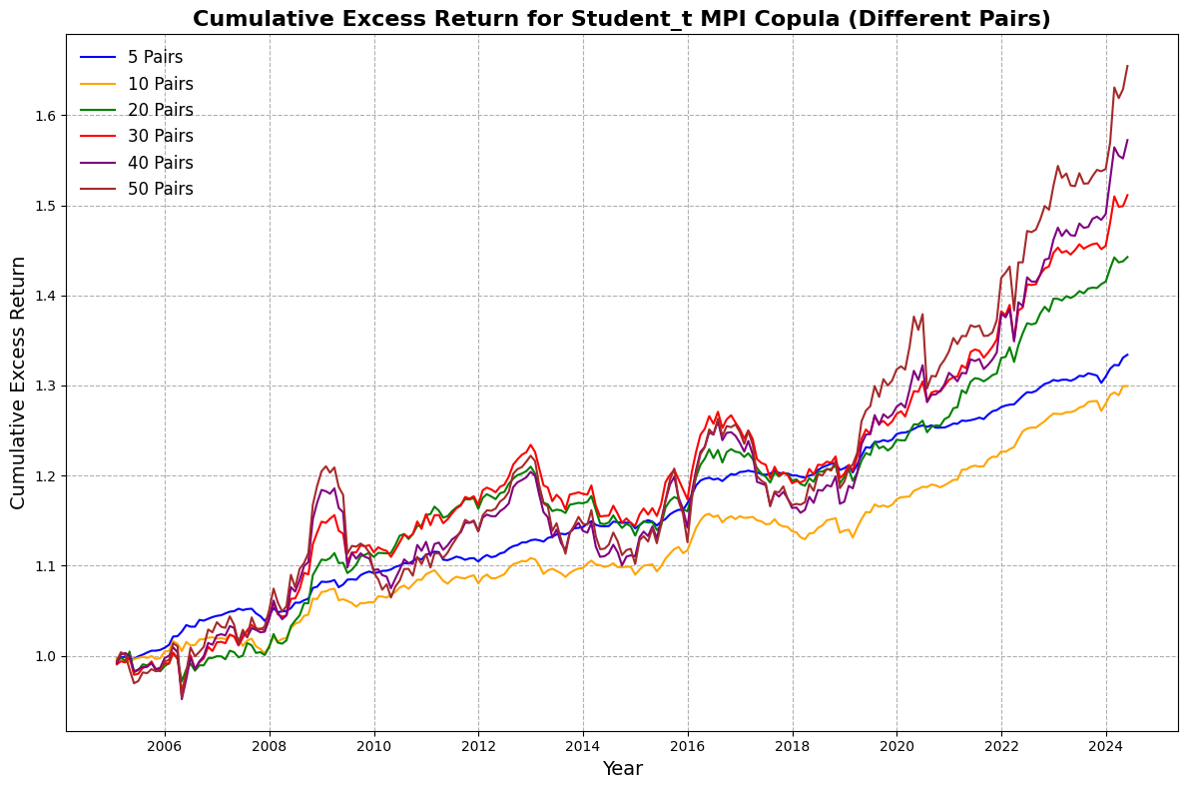

**Figure 5.** Cumulative excess return of different traded pairs for Student_t MPI copula.

Notes: This figure shows the evolution of wealth based upon an investment of 1 RMB for the student t copula method using six different traded pairs. Return on committed capital after transaction costs is applied to calculate the cumulative excess return.

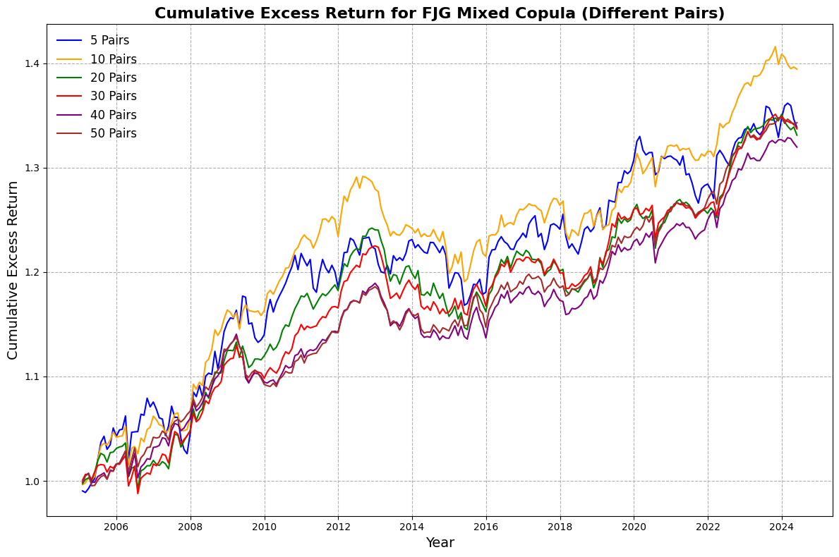

**Figure 6.** Cumulative excess return of different traded pairs for FJG mixed copula.

Notes: This figure shows the evolution of wealth based upon an investment of 1 RMB for the FJG mixed copula method using six different traded pairs. Return on committed capital after transaction costs is applied to calculate the cumulative excess return.

### 5.4.3 Varying Trading Period

In this section, we examine the sensitivity of the copula-based pairs trading strategies to different trading periods. Table 9 presents the performance metrics of the strategies with rebalancing periods of 3 months, 6 months, 9 months, and 12 months. The metrics include the mean monthly return on committed capital after accounting for trading costs, as well as the minimum, maximum, and standard deviation of the returns.

From Table 9, it is evident that the mean returns of the strategies are influenced by the rebalancing period. Specifically, the Student-t copula strategy consistently achieves the highest mean returns across all rebalancing periods, with the mean return decreasing from 0.0020 at the 3-month period to 0.0009 at the 12-month period, as shown in Figure 7. This suggests that the student-t copula strategy is more effective with shorter rebalancing intervals, likely due to its ability to capture short-term dependencies between asset pairs.

The Clayton and Gaussian copula strategies also display higher mean returns at shorter rebalancing periods. The Clayton copula strategy has a mean return of 0.0014 at the 3-month period, which decreases to 0.0012 at the 12-month period. Similarly, the Gaussian copula strategy's mean return decreases from 0.0015 to 0.0010 as the rebalancing period extends from 6 months to 12 months. This trend indicates that these strategies benefit from more frequent re-evaluation and rebalancing of pairs.

In contrast, the Frank copula strategy exhibits remarkable stability in mean returns across different rebalancing periods, maintaining mean returns between 0.0011 and 0.0012. This stability suggests that the Frank copula strategy is less sensitive to the choice of rebalancing period and may be more robust across different market conditions.

The Gumbel copula strategy shows the lowest mean returns among the individual copulas, ranging from 0.0005 to 0.0008. Its performance decreases with longer rebalancing periods, indicating that it may not be as effective over extended horizons. The higher standard deviations and extreme minimum returns at longer rebalancing periods suggest increased risk with less frequent rebalancing.

When examining the combined copula strategies, we observe that the CFG and FJG strategies maintain relatively stable mean returns across different rebalancing periods. The CFG strategy's mean return ranges from 0.0008 to 0.0012, while the FJG strategy's mean return decreases slightly from 0.0013 to 0.0010. These combined strategies may benefit from diversification across different copulas, leading to more consistent performance.

Analyzing the standard deviation of returns, we notice a general trend of decreasing volatility with longer rebalancing periods. For instance, the standard deviation for the Clayton copula strategy decreases from 0.0070 at the 3-month period to 0.0052 at the 12-month period. This inverse relationship between rebalancing frequency and return volatility is consistent across most strategies and aligns with the expectation that less frequent trading leads to smoother return profiles.

The maximum and minimum returns also provide insights into the strategies' risk profiles. The maximum returns generally decrease with longer rebalancing periods. For example, the maximum return for the Gaussian copula strategy decreases from 0.0293 at the 3-month period to 0.0220 at the 12-month period. Similarly, the minimum returns become less negative for some strategies as the rebalancing period increases, indicating reduced downside risk over longer horizons. However, exceptions exist; for instance, the Gumbel and Student-t copula strategies exhibit more negative minimum returns at longer rebalancing periods, suggesting higher tail risk.

Comparatively, the Student-t copula strategy not only achieves the highest mean returns but also maintains competitive maximum returns across rebalancing periods. However, it also exhibits relatively higher standard deviations and larger negative minimum returns, reflecting greater risk associated with the strategy. Traders employing the student-t copula strategy should be aware of this risk-return trade-off, especially when using shorter rebalancing periods.

The Optimal strategy, which presumably selects the best-performing copula at each period, shows mean returns around 0.0008 to 0.0010. Interestingly, its performance does not significantly exceed that of individual copula strategies like the student-t or Frank copulas. This could indicate that selecting a single copula strategy based on historical performance may not consistently outperform a static strategy.

The CJF and CJG strategies, which are combinations of different copulas, show varying sensitivities to rebalancing periods. The CJF strategy's mean return decreases from 0.0013 at the 3-month period to 0.0008 at the 12-month period, while the CJG strategy maintains a relatively stable mean return around 0.0007 to 0.0010, as shown in Figure 8. These observations suggest that combining copulas may help in stabilizing returns but may not necessarily enhance performance.

Comparing these findings to previous studies, we observe that the sensitivity of trading strategies to rebalancing periods is a common phenomenon. Similar to the correlation and cointegration methods discussed in earlier research, the copula-based strategies' performance varies with the rebalancing frequency. However, unlike some methods that fail to generate positive returns under certain rebalancing periods, the copula-based strategies generally produce positive mean returns after trading costs across all rebalancing periods considered.

In summary, the choice of rebalancing period significantly impacts the performance of copula-based pairs trading strategies. Shorter rebalancing periods tend to enhance mean returns but also increase volatility and risk. The student-t copula strategy stands out for its high mean returns at shorter rebalancing periods, albeit with higher risk. The Frank and CFG strategies offer more stable performance across different rebalancing periods, which may be preferable for risk-averse traders.

These results suggest that traders should carefully consider the trade-off between return and risk when selecting rebalancing periods and strategies. Additionally, the consistent positive returns after trading costs indicate that copula-based pairs trading can be a viable strategy under various rebalancing frequencies.

Overall, the copula-based methods demonstrate robustness and flexibility, with the potential to outperform traditional methods under certain conditions. The sensitivity analysis highlights the importance of rebalancing frequency in pairs trading and provides valuable insights for practitioners seeking to optimize their trading strategies.

**Table 9.** Copula Method’s Sensitivity Analysis with Various Trading Periods for Committed Capital Return After Trading Costs.

|  |  |  |  |  |  |
| --- | --- | --- | --- | --- | --- |
| Strategy | Trading Periods | 3 Months | 6 Months | 9 Months | 12 Months |
| Clayton | Mean | 0.0014 | 0.0007 | 0.0011 | 0.0012 |
|  | Min | -0.0194 | -0.0323 | -0.0196 | -0.0187 |
|  | Max | 0.0199 | 0.0239 | 0.0157 | 0.0178 |
|  | Std. Dev. | 0.0070 | 0.0069 | 0.0056 | 0.0052 |
| Frank | Mean | 0.0011 | 0.0012 | 0.0012 | 0.0011 |
|  | Min | -0.0300 | -0.0355 | -0.0277 | -0.0289 |
|  | Max | 0.0212 | 0.0154 | 0.0191 | 0.0165 |
|  | Std. Dev. | 0.0084 | 0.0069 | 0.0063 | 0.0060 |
| Gaussian | Mean | 0.0014 | 0.0015 | 0.0012 | 0.0010 |
|  | Min | -0.0335 | -0.0276 | -0.0269 | -0.0266 |
|  | Max | 0.0293 | 0.0244 | 0.0220 | 0.0220 |
|  | Std. Dev. | 0.0086 | 0.0072 | 0.0065 | 0.0064 |
| Gumbel | Mean | 0.0005 | 0.0008 | 0.0007 | 0.0005 |
|  | Min | -0.0339 | -0.0305 | -0.0579 | -0.0579 |
|  | Max | 0.0338 | 0.0269 | 0.0242 | 0.0207 |
|  | Std. Dev. | 0.0091 | 0.0072 | 0.0076 | 0.0073 |
| Student-t | Mean | 0.0020 | 0.0016 | 0.0013 | 0.0009 |
|  | Min | -0.0320 | -0.0248 | -0.0565 | -0.0565 |
|  | Max | 0.0247 | 0.0294 | 0.0283 | 0.0239 |
|  | Std. Dev. | 0.0086 | 0.0070 | 0.0077 | 0.0075 |
| Optimal | Mean | 0.0009 | 0.0008 | 0.0010 | 0.0010 |
|  | Min | -0.0288 | -0.0368 | -0.0280 | -0.0286 |
|  | Max | 0.0204 | 0.0133 | 0.0141 | 0.0154 |
|  | Std. Dev. | 0.0076 | 0.0063 | 0.0056 | 0.0054 |
| CFG | Mean | 0.0010 | 0.0008 | 0.0011 | 0.0012 |
|  | Min | -0.0260 | -0.0297 | -0.0303 | -0.0331 |
|  | Max | 0.0276 | 0.0201 | 0.0196 | 0.0184 |
|  | Std. Dev. | 0.0077 | 0.0067 | 0.0064 | 0.0062 |
| CJF | Mean | 0.0013 | 0.0011 | 0.0012 | 0.0008 |
|  | Min | -0.0301 | -0.0260 | -0.0301 | -0.0293 |
|  | Max | 0.0257 | 0.0216 | 0.0204 | 0.0158 |
|  | Std. Dev. | 0.0079 | 0.0068 | 0.0063 | 0.0060 |
| CJG | Mean | 0.0007 | 0.0009 | 0.0010 | 0.0008 |
|  | Min | -0.0384 | -0.0233 | -0.0249 | -0.0237 |
|  | Max | 0.0213 | 0.0247 | 0.0209 | 0.0173 |
|  | Std. Dev. | 0.0077 | 0.0066 | 0.0058 | 0.0058 |
| FJG | Mean | 0.0013 | 0.0013 | 0.0012 | 0.0010 |
|  | Min | -0.0304 | -0.0313 | -0.0302 | -0.0320 |
|  | Max | 0.0221 | 0.0198 | 0.0197 | 0.0144 |
|  | Std. Dev. | 0.0084 | 0.0073 | 0.0066 | 0.0061 |

Note: This table provides summary statistics for the sensitivity of monthly returns on committed capital for the copula-based trading strategies after accounting for trading costs. The sensitivity analysis is conducted across various trading periods, evaluating performance metrics such as the mean, minimum, maximum, and standard deviation of returns. The table highlights how different copula models perform under varying pairs, offering insights into their risk and return profiles.

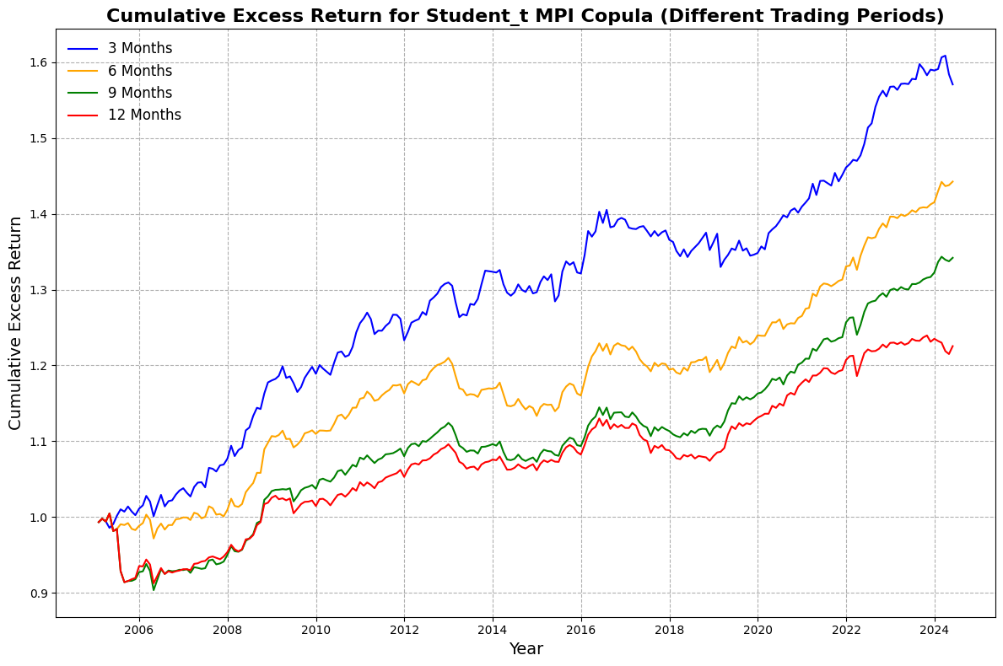

**Figure 7.** Cumulative excess return of different trading periods for Student_t MPI copula.

Notes: This figure shows the evolution of wealth based upon an investment of 1 RMB for the student t copula method using four different trading periods. Return on committed capital after transaction costs is applied to calculate the cumulative excess return.

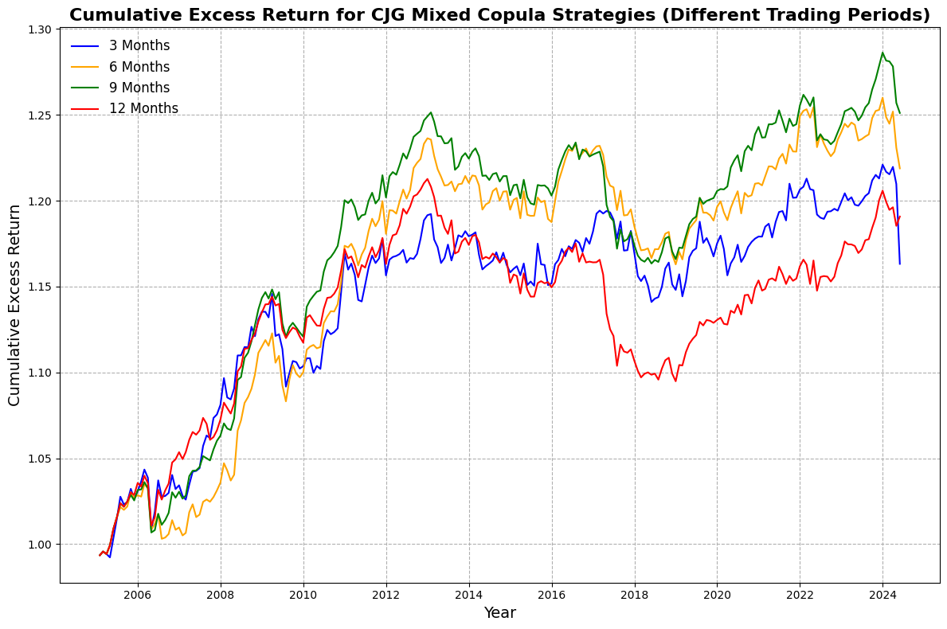

**Figure 8.** Cumulative excess return of different trading periods for CJG mixed copula.

Notes: This figure shows the evolution of wealth based upon an investment of 1 RMB for the CJG mixed copula method using four different trading periods. Return on committed capital after transaction costs is applied to calculate the cumulative excess return.

### 5.4.4 Varying Market Capitalization

In this section, we explore the sensitivity of copula-based pairs trading strategies to different market capitalizations. Table 10 presents the performance metrics of the strategies when applied to stocks from various indices: CSI100 (large-cap stocks), CSI200 (mid-cap stocks), CSI500 (small-cap stocks), and All (the entire market). The metrics include the mean monthly return on committed capital after accounting for trading costs, as well as the minimum, maximum, and standard deviation of the returns.

Firstly, the mean returns vary significantly depending on the market capitalization. The highest mean returns are achieved when trading small-cap stocks. For instance, the student-t copula strategy yields a mean return of 0.0016, and the CFG strategy achieves the highest mean return of 0.0019 in this category. Small-cap stocks are often less efficiently priced and may offer more arbitrage opportunities due to higher volatility and lower analyst coverage.

In contrast, mean returns are generally lower for large-cap stocks. The Gumbel copula strategy shows a minimal mean return of 0.0001, while the CFG strategy provides a slightly higher mean return of 0.0011. Large-cap stocks are more efficiently priced, which may reduce the number of profitable mispricings that pairs trading strategies can exploit. The performance in mid-cap stocks is mixed. The Clayton and Student-t strategies achieve mean returns of 0.0011 and 0.0012, respectively. However, some strategies like the Frank copula yield a negative mean return (-0.0003), indicating potential challenges in this market segment.

When considering the entire market, mean returns are generally lower than those achieved in the small-cap segment but higher than in the large-cap segment. The student-t copula strategy maintains a relatively high mean return of 0.0016, suggesting its robustness across different market capitalizations.

Secondly, the standard deviation and the minimum and maximum returns provide insights into the risk associated with each strategy. Strategies applied to CSI200 stocks exhibit significantly higher standard deviations. For example, the Clayton strategy has a standard deviation of 0.0226 when trading CSI200 stocks, compared to 0.0065 for CSI100 and 0.0061 for CSI500. This increased volatility suggests higher risk when trading mid-cap stocks, possibly due to less liquidity and greater price fluctuations.

The most extreme negative returns often occur in the CSI200 segment. The Clayton strategy experiences a minimum return of -0.0925, and the Gumbel strategy reaches -0.0998. Such large drawdowns indicate that mid-cap stocks can be particularly risky, possibly due to sudden market movements or lower trading volumes exacerbating price swings. Despite the higher risks, trading CSI200 stocks can also yield exceptionally high maximum returns. The Clayton strategy achieves a maximum return of 0.3134, and the CFG strategy reaches 0.2987. These high returns highlight the potential for significant profits when correctly capturing market inefficiencies in mid-cap stocks.

Thirdly, comparing the performance of different strategies, the student-t copula strategy consistently delivers strong mean returns across all market capitalizations, with particularly high performance in the CSI500 and All categories. Its ability to model fat tails and capture extreme co-movements between asset pairs may contribute to its effectiveness. The Clayton copula strategy shows good performance in the CSI200 and CSI500 segments but lower mean returns in the CSI100 and All categories. Its focus on lower tail dependence might make it more suitable for assets that exhibit joint downside movements, which could be more prevalent in mid-cap and small-cap stocks.

The Frank copula strategy yields a negative mean return in the CSI200 category (-0.0003), suggesting it may not be well-suited for mid-cap stocks. However, it performs better in the CSI500 and All categories, indicating a potential preference for trading small-cap stocks. The Gaussian copula strategy shows modest mean returns across all market capitalizations, with slightly better performance in the CSI500 category. Its assumption of normal dependence may limit its effectiveness in markets where asset returns exhibit significant skewness or kurtosis.

Combined copula strategies such as CFG, CJF, CJG, and FJG generally perform well in the CSI500 category, with the CFG strategy achieving the highest mean return of 0.0019. This suggests that combining different copulas can enhance performance, possibly by capturing a wider range of dependence structures between asset pairs.

These results have important implications for trading strategies. The higher mean returns in small-cap stocks suggest that these stocks are less efficiently priced, providing more arbitrage opportunities for pairs trading strategies. Traders may find more mispricings to exploit in this segment due to factors like lower analyst coverage and less institutional investment. However, while the CSI200 category offers high maximum returns, the associated risks are also substantial, as indicated by the high standard deviations and extreme minimum returns. Traders need to consider the risk-adjusted returns and may require robust risk management strategies when trading mid-cap stocks.

Liquidity considerations are also important. Small-cap and mid-cap stocks often have lower liquidity compared to large-cap stocks. This can lead to higher transaction costs and slippage, which can erode profits. The fact that the strategies still yield higher mean returns after accounting for trading costs suggests that the profits are sufficient to overcome these challenges in the small-cap segment.

Comparing these findings to previous studies, the sensitivity of pairs trading strategies to market capitalization aligns with prior research, where small-cap stocks often offer higher returns but with increased risk. However, unlike some traditional pairs trading methods that may struggle with liquidity issues in small-cap stocks, the copula-based strategies appear to manage these challenges effectively.

The consistent performance of the student-t copula strategy across different market capitalizations indicates its robustness and adaptability. This contrasts with some studies where strategies perform well only in specific market segments. The ability of the student-t copula to model fat tails and capture extreme market movements likely contributes to its effectiveness across varying market capitalizations.

In conclusion, the sensitivity analysis of copula-based pairs trading strategies across different market capitalizations reveals that small-cap stocks offer the highest mean returns, albeit with acceptable levels of risk as indicated by standard deviations. The student-t and CFG copula strategies stand out for their strong performance in this segment. Large-cap stocks yield lower mean returns, reflecting their higher market efficiency and fewer arbitrage opportunities.

The findings suggest that traders can potentially enhance their returns by focusing on small-cap stocks and selecting appropriate copula models that capture the dependence structures inherent in this market segment. However, they should also be cautious of the risks associated with less liquid markets and implement robust risk management practices. Overall, the copula-based pairs trading strategies demonstrate versatility and effectiveness across different market capitalizations, providing valuable tools for traders seeking to exploit market inefficiencies while managing risk.

**Table 10.** Copula Method’s Sensitivity Analysis with Various Market Capitalizations for Committed Capital Return After Trading Costs.

|  |  |  |  |  |  |
| --- | --- | --- | --- | --- | --- |
| Strategy | Trading Periods | CSI100 | CSI200 | CSI500 | All |
| Clayton | Mean | 0.0009 | 0.0011 | 0.0012 | 0.0007 |
|  | Min | -0.0258 | -0.0925 | -0.0143 | -0.0323 |
|  | Max | 0.0240 | 0.3134 | 0.0263 | 0.0239 |
|  | Std. Dev. | 0.0065 | 0.0226 | 0.0061 | 0.0069 |
| Frank | Mean | 0.0004 | -0.0003 | 0.0017 | 0.0012 |
|  | Min | -0.0340 | -0.0352 | -0.0241 | -0.0355 |
|  | Max | 0.0139 | 0.0194 | 0.0247 | 0.0154 |
|  | Std. Dev. | 0.0059 | 0.0077 | 0.0073 | 0.0069 |
| Gaussian | Mean | 0.0008 | 0.0003 | 0.0016 | 0.0015 |
|  | Min | -0.0289 | -0.1093 | -0.0344 | -0.0276 |
|  | Max | 0.0214 | 0.0904 | 0.0227 | 0.0244 |
|  | Std. Dev. | 0.0061 | 0.0120 | 0.0072 | 0.0072 |
| Gumbel | Mean | 0.0001 | -0.0001 | 0.0009 | 0.0008 |
|  | Min | -0.0327 | -0.0998 | -0.0182 | -0.0305 |
|  | Max | 0.0183 | 0.0478 | 0.0202 | 0.0269 |
|  | Std. Dev. | 0.0060 | 0.0111 | 0.0067 | 0.0072 |
| Student-t | Mean | 0.0005 | 0.0012 | 0.0016 | 0.0016 |
|  | Min | -0.0297 | -0.0311 | -0.0359 | -0.0248 |
|  | Max | 0.0230 | 0.0980 | 0.0254 | 0.0294 |
|  | Std. Dev. | 0.0061 | 0.0110 | 0.0074 | 0.0070 |
| Optimal | Mean | 0.0005 | 0.0004 | 0.0015 | 0.0008 |
|  | Min | -0.0389 | -0.0302 | -0.0210 | -0.0368 |
|  | Max | 0.0224 | 0.0931 | 0.0219 | 0.0133 |
|  | Std. Dev. | 0.0065 | 0.0101 | 0.0067 | 0.0063 |
| CFG | Mean | 0.0011 | 0.0009 | 0.0019 | 0.0008 |
|  | Min | -0.0412 | -0.0999 | -0.0201 | -0.0297 |
|  | Max | 0.0250 | 0.2987 | 0.0254 | 0.0201 |
|  | Std. Dev. | 0.0065 | 0.0218 | 0.0064 | 0.0067 |
| CJF | Mean | 0.0009 | 0.0008 | 0.0013 | 0.0011 |
|  | Min | -0.0214 | -0.1014 | -0.0191 | -0.0260 |
|  | Max | 0.0207 | 0.2809 | 0.0274 | 0.0216 |
|  | Std. Dev. | 0.0060 | 0.0210 | 0.0066 | 0.0068 |
| CJG | Mean | 0.0008 | 0.0007 | 0.0013 | 0.0009 |
|  | Min | -0.0224 | -0.0851 | -0.0161 | -0.0233 |
|  | Max | 0.0211 | 0.2040 | 0.0258 | 0.0247 |
|  | Std. Dev. | 0.0062 | 0.0163 | 0.0064 | 0.0066 |
| FJG | Mean | 0.0005 | 0.0007 | 0.0017 | 0.0013 |
|  | Min | -0.0342 | -0.0350 | -0.0231 | -0.0313 |
|  | Max | 0.0188 | 0.1419 | 0.0215 | 0.0198 |
|  | Std. Dev. | 0.0063 | 0.0120 | 0.0070 | 0.0073 |

Note: This table provides summary statistics for the sensitivity of monthly returns on committed capital for the copula-based trading strategies after accounting for trading costs. The sensitivity analysis is conducted across various market capitalizations, evaluating performance metrics such as the mean, minimum, maximum, and standard deviation of returns. The table highlights how different copula models perform under varying pairs, offering insights into their risk and return profiles.

## 5.5 Sub-period Performance Analysis

In this section, we conduct a sub-period performance analysis of the copula-based pairs trading strategies to assess their robustness across different market conditions and economic cycles. Table 11 and Figure 9 present the mean and standard deviation of monthly returns before and after transaction costs for each strategy over nine distinct sub-periods. These sub-periods encompass significant financial events and market phases, as shown in Figure 10, including the Pre-Financial Crisis (Jan 2005–Dec 2006), In-Financial Crisis (Jan 2007–Dec 2008), Post-Financial Crisis (Jan 2009–Dec 2010), Pre-Bullish and Non-Bullish (Jan 2011–Dec 2013), In-Bullish (Jan 2014–May 2015), In-Bearish (June 2015–Dec 2016), Pre-COVID-19 (Jan 2017–Dec 2019), In-COVID-19 (Jan 2020–Dec 2022), and Post-COVID-19 (Jan 2023–June 2024) periods.

The sub-period analysis provides valuable insights into how the copula-based pairs trading strategies perform under varying market conditions and significant economic events. By examining the mean returns and standard deviations before and after transaction costs, we can assess the strategies' profitability and risk across different periods.

During the In-Financial Crisis period (Jan 2007–Dec 2008), most strategies exhibit their highest mean returns before transaction costs. For instance, the Clayton copula strategy achieves a mean return of 1.05%, and the Gaussian copula strategy yields a mean return of 0.94%. This period is characterized by heightened market volatility and increased co-movement among assets, which may enhance the effectiveness of pairs trading strategies that capitalize on temporary divergences. After accounting for transaction costs, the mean returns decrease but remain positive. The Clayton strategy's mean return drops to 0.86%, and the Gaussian strategy's mean return reduces to 0.83%. The relatively modest impact of transaction costs during this period suggests that the high volatility provided ample trading opportunities with sufficient profit margins to cover costs.

In the In-Bullish period (Jan 2014–May 2015), the strategies generally underperform compared to other periods. The Clayton strategy records a negative mean return of -0.37% before transaction costs, which further declines to -0.45% after costs. Similarly, the Frank and Gaussian strategies also exhibit negative mean returns after costs during this period. This underperformance can be attributed to the nature of bullish markets, where strong upward trends reduce the frequency of mean-reverting price movements that pairs trading strategies rely on. Conversely, during the In-Bearish period (June 2015–Dec 2016), the strategies' performances improve significantly. The Clayton strategy achieves a mean return of 0.64% before costs and 0.49% after costs. The Frank and Gaussian strategies also record positive mean returns after costs of 0.70% and 0.36%, respectively. The better performance in bearish markets may be attributed to increased volatility and mean-reversion tendencies, which are favorable conditions for pairs trading.

The In-COVID-19 period (Jan 2020–Dec 2022) presents unique challenges due to unprecedented market disruptions and volatility spikes. Interestingly, the strategies demonstrate resilience during this period. The Clayton strategy yields a mean return of 0.34% before costs and 0.20% after costs. The student-t copula strategy performs notably well, with a mean return of 0.46% before costs and 0.61% after costs, indicating that it benefits from the heavy tails and extreme co-movements prevalent during the pandemic. This suggests that strategies capable of capturing tail dependencies and extreme market movements can maintain profitability even in highly uncertain environments.

In the Post-Financial Crisis (Jan 2009–Dec 2010) and Post-COVID-19 (Jan 2023–June 2024) periods, the strategies exhibit mixed performances. The Clayton strategy records a modest mean return of 0.09% before costs and 0.04% after costs in the Post-Financial Crisis period. In the Post-COVID-19 period, the mean return is 0.11% before costs and effectively zero after costs. These results suggest that as markets stabilize after crises, the opportunities for pairs trading diminish due to reduced volatility and less frequent price divergences. The decreased profitability underscores the importance of market conditions in influencing strategy effectiveness.

The student-t copula strategy exhibits consistent performance across most periods, especially during turbulent times like the In-Financial Crisis and In-COVID-19 periods. Its ability to model fat tails and capture extreme co-movements between asset pairs contributes to its robustness. The Clayton copula strategy performs exceptionally well during crisis periods and bearish markets, likely due to its focus on lower tail dependence, which captures joint downside movements. The Frank and Gaussian copula strategies show variability in performance, with strong results during crises but weaker performance in bullish markets. The Gaussian copula's assumption of normal dependence may limit its effectiveness in markets with non-normal behaviors.

Combined copula strategies, such as CFG, CJF, CJG, and FJG, generally exhibit smoother performance across periods, suggesting that combining copulas can diversify risk and enhance stability. However, their mean returns after costs are often lower than the best-performing individual copulas during peak periods. This indicates a trade-off between achieving consistent performance and maximizing returns.

Transaction costs significantly impact the profitability of the strategies, especially in periods with lower volatility and fewer trading opportunities. The difference between before-cost and after-cost mean returns is more pronounced during stable periods like Pre-Bullish and Non-Bullish (Jan 2011–Dec 2013) and Post-Crisis periods. This underscores the importance of accounting for trading costs when evaluating strategy performance. In high-volatility periods, the larger profit margins per trade help offset transaction costs, whereas in stable periods, the thinner margins make costs more burdensome.

The number of trading opportunities varies across periods, influenced by market volatility and the frequency of price divergences. During high-volatility periods like the In-Financial Crisis and In-Bearish markets, increased trade counts contribute to higher mean returns. In contrast, during stable or bullish markets, fewer divergences lead to reduced trade frequency and lower returns. This relationship highlights the dependence of pairs trading strategies on market dynamics and the importance of adapting trading intensity accordingly.

The sub-period analysis highlights that copula-based pairs trading strategies are more effective during periods of market stress and high volatility. Traders may achieve better results by adjusting their trading intensity based on market conditions, increasing activity during volatile periods and exercising caution during stable or bullish markets. The consistent performance of the student-t copula strategy suggests it may be a preferred choice for traders seeking robustness across different market environments. Its capacity to model extreme events makes it particularly suited for periods characterized by significant market movements.

While the strategies demonstrate varying degrees of success across sub-periods, it is important to acknowledge limitations. The historical analysis may not fully capture future market dynamics, especially considering structural changes in markets over time. Additionally, the impact of factors such as regulatory changes, technological advancements, and evolving market participant behaviors are not explicitly accounted for in this analysis. Future research could explore adaptive strategies that adjust parameters in real-time based on market indicators. Incorporating machine learning techniques to predict volatility regimes or identify optimal copula selections for different market conditions may further enhance strategy performance.

In conclusion, the sub-period performance analysis reveals that copula-based pairs trading strategies are sensitive to market conditions, performing best during periods of high volatility and market stress, such as financial crises and bearish markets. Strategies like the Student-t and Clayton copulas, which capture extreme co-movements and lower tail dependencies, offer robust performance across various periods. Transaction costs play a crucial role in determining the net profitability of the strategies, particularly during periods with fewer trading opportunities. Traders should carefully consider these costs and may benefit from focusing on periods or markets where volatility is higher, and the frequency of profitable trades is greater. Overall, the copula-based methods provide valuable tools for pairs trading, with the potential to adapt to different market environments. By understanding the strengths and limitations of each strategy across sub-periods, traders can make informed decisions to optimize their trading performance.

**Table 11.** Copula Method’s Sub-Period Performance of Pairs Trading Strategies.

|  |  |  |  |  |  |  |  |  |  |  |
| --- | --- | --- | --- | --- | --- | --- | --- | --- | --- | --- |
| Strategy | Sub-Period | Pre- Fin.C. | In- Fin.C. | Post- Fin.C. | Pre-B.N.B. | In-Bullish | In-Bearish | Pre-Cov. | In-Cov. | Post-Cov. |
|  | Timeline | Jan 2005-Dec 2006 | Jan 2007-Dec 2008 | Jan 2009-Dec 2010 | Jan 2011-Dec 2013 | Jan 2014-May 2015 | June 2015-Dec 2016 | Jan 2017-Dec 2019 | Jan 2020-Dec 2022 | Jan 2023-June 2024 |
| *Panel A: Before Transaction Costs* | | | | | | | | | | |
| Clayton | Mean | 0.0030 | 0.0105 | 0.0009 | 0.0006 | -0.0037 | 0.0064 | -0.0004 | 0.0034 | 0.0011 |
|  | Std. Dev. | 0.0156 | 0.0160 | 0.0179 | 0.0095 | 0.0109 | 0.0228 | 0.0084 | 0.0097 | 0.0155 |
| Frank | Mean | -0.0002 | 0.0067 | 0.0046 | 0.0012 | -0.0038 | 0.0083 | 0.0002 | 0.0067 | -0.0021 |
|  | Std. Dev. | 0.0155 | 0.0125 | 0.0091 | 0.0094 | 0.0109 | 0.0198 | 0.0131 | 0.0099 | 0.0090 |
| Gaussian | Mean | 0.0018 | 0.0094 | 0.0044 | 0.0014 | -0.0037 | 0.0046 | -0.0012 | 0.0071 | 0.0020 |
|  | Std. Dev. | 0.0147 | 0.0133 | 0.0075 | 0.0123 | 0.0125 | 0.0160 | 0.0128 | 0.0112 | 0.0094 |
| Gumbel | Mean | 0.0030 | 0.0056 | 0.0019 | 0.0014 | -0.0034 | 0.0041 | -0.0002 | 0.0050 | -0.0002 |
|  | Std. Dev. | 0.0165 | 0.0139 | 0.0104 | 0.0108 | 0.0124 | 0.0113 | 0.0151 | 0.0110 | 0.0105 |
| Student-t | Mean | 0.0039 | 0.0055 | 0.0025 | 0.0012 | 0.0010 | 0.0045 | 0.0017 | 0.0046 | -0.0010 |
|  | Std. Dev. | 0.0215 | 0.0142 | 0.0160 | 0.0082 | 0.0087 | 0.0150 | 0.0143 | 0.0139 | 0.0157 |
| Optimal | Mean | -0.0002 | 0.0033 | 0.0037 | 0.0019 | -0.0020 | 0.0072 | -0.0019 | 0.0053 | -0.0010 |
|  | Std. Dev. | 0.0132 | 0.0119 | 0.0099 | 0.0095 | 0.0080 | 0.0129 | 0.0153 | 0.0083 | 0.0076 |
| CFG | Mean | -0.0007 | 0.0055 | 0.0059 | 0.0031 | -0.0014 | 0.0029 | -0.0017 | 0.0040 | -0.0016 |
|  | Std. Dev. | 0.0138 | 0.0121 | 0.0107 | 0.0092 | 0.0077 | 0.0117 | 0.0113 | 0.0105 | 0.0116 |
| CJF | Mean | -0.0006 | 0.0054 | 0.0051 | 0.0022 | -0.0019 | 0.0073 | -0.0017 | 0.0047 | 0.0007 |
|  | Std. Dev. | 0.0153 | 0.0099 | 0.0100 | 0.0126 | 0.0112 | 0.0158 | 0.0129 | 0.0108 | 0.0074 |
| CJG | Mean | 0.0019 | 0.0075 | 0.0047 | 0.0028 | -0.0021 | 0.0034 | -0.0016 | 0.0041 | -0.0015 |
|  | Std. Dev. | 0.0129 | 0.0130 | 0.0120 | 0.0119 | 0.0123 | 0.0102 | 0.0136 | 0.0125 | 0.0115 |
| FJG | Mean | 0.0010 | 0.0066 | 0.0039 | 0.0014 | -0.0038 | 0.0071 | 0.0012 | 0.0043 | -0.0002 |
|  | Std. Dev. | 0.0160 | 0.0143 | 0.0086 | 0.0095 | 0.0124 | 0.0144 | 0.0119 | 0.0123 | 0.0057 |
| *Panel B: After Transaction Costs* | | | | | | | | | | |
| Clayton | Mean | 0.0020 | 0.0086 | 0.0004 | -0.0005 | -0.0045 | 0.0049 | -0.0019 | 0.0020 | 0.0000 |
|  | Std. Dev. | 0.0150 | 0.0151 | 0.0176 | 0.0094 | 0.0105 | 0.0219 | 0.0083 | 0.0093 | 0.0148 |
| Frank | Mean | -0.0014 | 0.0053 | 0.0037 | 0.0003 | -0.0048 | 0.0070 | -0.0009 | 0.0056 | -0.0030 |
|  | Std. Dev. | 0.0150 | 0.0118 | 0.0089 | 0.0094 | 0.0107 | 0.0190 | 0.0129 | 0.0094 | 0.0090 |
| Gaussian | Mean | 0.0008 | 0.0083 | 0.0035 | 0.0004 | -0.0048 | 0.0036 | -0.0021 | 0.0058 | 0.0004 |
|  | Std. Dev. | 0.0144 | 0.0126 | 0.0074 | 0.0122 | 0.0126 | 0.0156 | 0.0122 | 0.0109 | 0.0094 |
| Gumbel | Mean | 0.0017 | 0.0040 | 0.0010 | 0.0003 | -0.0048 | 0.0026 | -0.0014 | 0.0036 | -0.0016 |
|  | Std. Dev. | 0.0160 | 0.0136 | 0.0103 | 0.0106 | 0.0122 | 0.0108 | 0.0146 | 0.0109 | 0.0101 |
| Student-t | Mean | 0.0006 | 0.0081 | 0.0030 | 0.0000 | -0.0049 | 0.0055 | -0.0011 | 0.0061 | 0.0025 |
|  | Std. Dev. | 0.0126 | 0.0142 | 0.0105 | 0.0109 | 0.0111 | 0.0147 | 0.0128 | 0.0107 | 0.0089 |
| Optimal | Mean | -0.0009 | 0.0022 | 0.0029 | 0.0010 | -0.0028 | 0.0060 | -0.0028 | 0.0042 | -0.0018 |
|  | Std. Dev. | 0.0129 | 0.0118 | 0.0096 | 0.0094 | 0.0077 | 0.0126 | 0.0145 | 0.0081 | 0.0075 |
| CFG | Mean | -0.0017 | 0.0043 | 0.0050 | 0.0021 | -0.0023 | 0.0017 | -0.0028 | 0.0029 | -0.0026 |
|  | Std. Dev. | 0.0135 | 0.0116 | 0.0103 | 0.0088 | 0.0075 | 0.0114 | 0.0109 | 0.0102 | 0.0114 |
| CJF | Mean | -0.0015 | 0.0043 | 0.0041 | 0.0012 | -0.0026 | 0.0059 | -0.0027 | 0.0035 | -0.0005 |
|  | Std. Dev. | 0.0150 | 0.0102 | 0.0097 | 0.0122 | 0.0107 | 0.0154 | 0.0126 | 0.0106 | 0.0072 |
| CJG | Mean | 0.0006 | 0.0070 | 0.0039 | 0.0016 | -0.0033 | 0.0023 | -0.0027 | 0.0027 | -0.0023 |
|  | Std. Dev. | 0.0127 | 0.0123 | 0.0117 | 0.0116 | 0.0119 | 0.0102 | 0.0131 | 0.0124 | 0.0107 |
| FJG | Mean | -0.0002 | 0.0052 | 0.0031 | 0.0005 | -0.0048 | 0.0056 | 0.0002 | 0.0032 | -0.0010 |
|  | Std. Dev. | 0.0156 | 0.0144 | 0.0083 | 0.0094 | 0.0121 | 0.0134 | 0.0116 | 0.0119 | 0.0052 |

Note: This table presents the sub-period performance of pairs trading strategies using different Copula methods before and after trading costs. The strategies are analyzed across various key economic and market periods. The period is segmented into three key timeframes: Pre-Financial Crisis (Pre-Fin.C.), In-Financial Crisis (In-Fin.C.), and Post-Financial Crisis (Post-Fin.C.) periods; Pre-Bullish and Non-Bullish (Pre-B.N.B.), In-Bullish, and In-Bearish periods; as well as Pre-COVID-19 (Pre-Cov.), In-COVID-19 (In-Cov.), and Post-COVID-19 (Post-Cov.) periods.

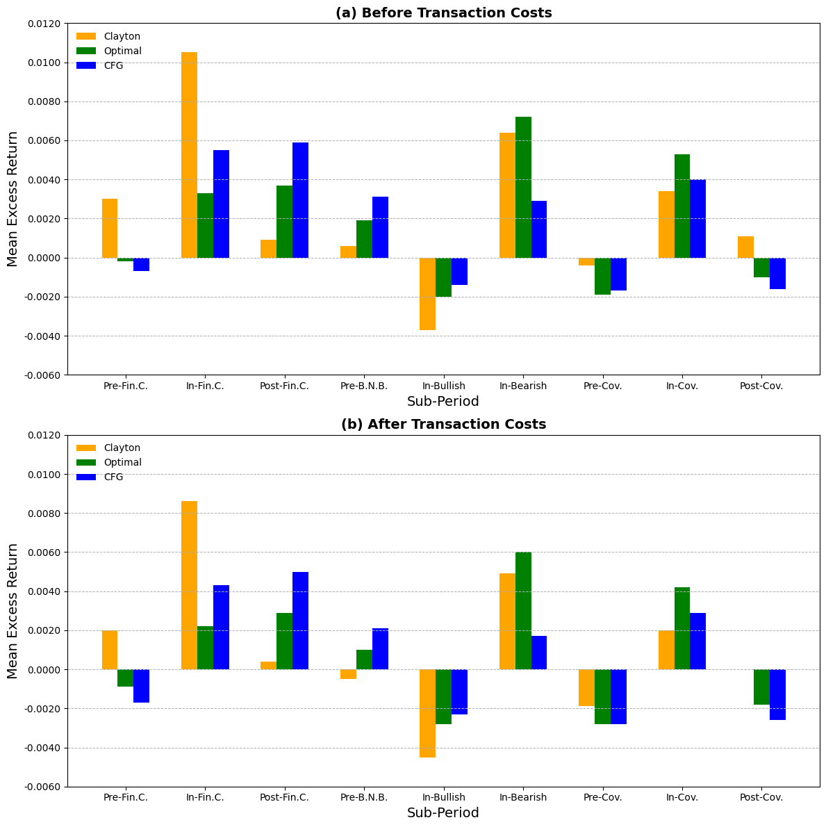

**Figure 9.** Sub-period performance of pairs trading strategies.

Notes: This figure shows the performance metrics of each strategy in five-year periods. (a), (b) shows the mean monthly excess returns after (before) transaction costs.

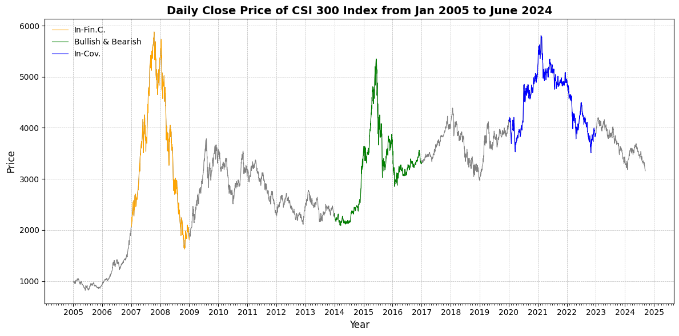

**Figure 10.** Daily close price of the CSI 300 index.

This figure shows the daily close price trend of the CSI 300 Index from January 2005 to June 2024, highlighting three key periods: the Financial Crisis (January 2007-December 2008), the Bullish and Bearish Market Phase (January 2014-December 2016), and the COVID-19 Pandemic Period (January 2020-December 2022).

## 5.6. Crisis Versus Non-Crisis

In this section, we compare the performance of the copula-based pairs trading strategies during crisis and normal periods to evaluate their effectiveness under different market conditions. The analysis of trading strategies during crisis periods is particularly important for risk-averse investors who seek assets that can serve as safe havens or hedges during market downturns. In our study, "Crisis" periods are defined as time frames when the market exhibited its worst performance. These periods include the In-Financial Crisis (In-Fin.C.), which spans from January 2007 to December 2008, and the Bullish and Bearish Period, from January 2014 to December 2016, which encompasses both upward and downward market conditions. Additionally, we consider the In-COVID-19 (In-Cov.) period, from January 2020 to December 2022, when the market experienced heightened volatility due to the global pandemic.

The "Normal" period, in contrast, consists of the remaining months in our sample that do not fall within these crisis periods. By examining the performance of each strategy under both crisis and normal market conditions, we aim to understand their resilience and adaptability. Table 12 presents the average monthly performance metrics of each strategy during the crisis and normal periods, with trading costs accounted for. The performance metrics include the Sharpe Ratio, which measures risk-adjusted returns, the Sortino Ratio, which focuses on downside risk, and the Mean Conditional Value at Risk (Mean/CVaR) at the 95% confidence level, which assesses the strategies’ effectiveness in limiting extreme losses.

During the crisis periods, the SSD-Hurst and SSD-NZC strategies outperform the copula-based strategies, achieving the highest Sharpe Ratios of 0.4749 and 0.3969, respectively. The SSD-Hurst strategy also records a remarkable Sortino Ratio of 0.8386 and a Mean/CVaR(95%) of 0.3052, indicating strong returns relative to downside risk. These results suggest that strategies based on stochastic dominance and the Hurst exponent are particularly effective during periods of market turmoil.

Among the copula-based strategies, the Student-t copula strategy stands out with a Sharpe Ratio of 0.3384, a Sortino Ratio of 0.6686, and a Mean/CVaR(95%) of 0.2213. This performance can be attributed to the student-t copula's ability to model fat tails and capture extreme co-movements between asset pairs, which are prevalent during crisis periods. The Gaussian and Frank copula strategies also perform well, with Sharpe Ratios of 0.3065 and 0.2961, respectively. The Optimal copula strategy, which selects the best-performing copula model dynamically, achieves a Sharpe Ratio of 0.2649 and a Sortino Ratio of 0.4197. This indicates that adaptive strategies that adjust to changing market dependence structures can be effective during crises. Combined copula strategies like CJF and CJG also show strong performance, suggesting that diversification across different copula models enhances robustness in turbulent markets.

In normal periods, the performance of most strategies declines noticeably. The SSD-Hurst strategy maintains a positive Sharpe Ratio of 0.1920 and an impressive Sortino Ratio of 1.1439, indicating that it continues to generate returns with relatively low downside risk. The high Sortino Ratio suggests that the strategy's returns are consistent and exhibit limited volatility below the target return.

However, many copula-based strategies show diminished performance during normal periods. The Clayton, Frank, Gumbel, and Optimal strategies exhibit negative Sharpe Ratios and Sortino Ratios, indicating that they failed to generate sufficient returns to compensate for the risk undertaken. The negative Mean/CVaR(95%) values further highlight the unfavorable risk-return trade-offs during these periods.

Some copula strategies, such as the student-t and FJG, manage to maintain positive Sharpe Ratios of 0.0561 and 0.0508, respectively. This suggests that strategies capable of capturing a broader range of dependence structures, including tail dependencies, can still find profitable opportunities in stable markets, albeit less frequently.

The contrasting performance between crisis and normal periods underscores the importance of market conditions in the effectiveness of pairs trading strategies. During crisis periods, heightened volatility and increased asset price divergences create more opportunities for pairs trading strategies to exploit mean-reverting behaviors. The superior performance of the SSD-Hurst, SSD-NZC, and Student-t copula strategies during crises indicates their potential as valuable tools for portfolio diversification and risk management.

In normal market conditions, the reduced volatility and fewer mispricing opportunities limit the effectiveness of many pairs trading strategies. Negative risk-adjusted returns suggest that transaction costs and the lack of significant price deviations erode potential profits. Investors should exercise caution when employing these strategies during stable periods and consider adjusting their exposure or employing more selective criteria for trade initiation.

The findings align with the theory that market-neutral strategies like pairs trading are more beneficial during periods of market stress. In crises, correlations between assets often increase, but so do temporary dislocations due to panic selling or rapid adjustments in asset prices. Pairs trading strategies can capitalize on these dislocations when assets deviate from their historical relationships.

The comparative analysis of pairs trading strategies during crisis and normal periods reveals that their performance is significantly influenced by market conditions. Strategies like SSD-Hurst and Student-t copulas perform exceptionally well during crises, offering high risk-adjusted returns and effective downside risk management. These strategies can serve as valuable components in a diversified investment portfolio, providing protection and potential profits during periods when traditional assets may underperform.

In contrast, the diminished performance of many strategies during normal periods highlights the need for strategic discretion. Investors should consider the prevailing market environment and may opt to reduce exposure to pairs trading strategies when volatility is low and mispricing opportunities are scarce.

Overall, the findings support the strategic use of pairs trading as a dynamic tool that can adapt to market conditions, enhancing portfolio performance during crises while requiring careful management during stable periods.

**Table 12.** Average Monthly Performance in Normal and Crisis Periods after Trading Costs.

|  |  |  |  |
| --- | --- | --- | --- |
| Strategy | Sharpe Ratio | Sortino Ratio | Mean/CVaR(95%) |
| *Panel A: Average monthly performance in crisis period* | | | |
| SSD-Hurst | 0.4749 | 0.8386 | 0.3052 |
| SSD-NZC | 0.3969 | 0.6701 | 0.2237 |
| Clayton | 0.2038 | 0.2788 | 0.0926 |
| Frank | 0.2961 | 0.5967 | 0.1924 |
| Gaussian | 0.3065 | 0.5248 | 0.1687 |
| Gumbel | 0.1632 | 0.2494 | 0.0757 |
| Student-t | 0.3384 | 0.6686 | 0.2213 |
| Optimal | 0.2649 | 0.4197 | 0.1376 |
| CFG | 0.1943 | 0.2867 | 0.0917 |
| CJF | 0.2576 | 0.4533 | 0.1478 |
| CJG | 0.2138 | 0.3473 | 0.1106 |
| FJG | 0.2030 | 0.3183 | 0.1062 |
| *Panel B: Average monthly performance in normal period* | | | |
| SSD-Hurst | 0.1920 | 1.1439 | 0.4672 |
| SSD-NZC | 0.1798 | 0.5460 | 0.2267 |
| Clayton | -0.0147 | -0.0177 | -0.0055 |
| Frank | -0.0104 | -0.0126 | -0.0037 |
| Gaussian | 0.0323 | 0.0443 | 0.0139 |
| Gumbel | -0.0010 | -0.0013 | -0.0004 |
| Student-t | 0.0561 | 0.0767 | 0.0235 |
| Optimal | -0.0305 | -0.0365 | -0.0111 |
| CFG | 0.0061 | 0.0079 | 0.0024 |
| CJF | -0.0007 | -0.0008 | -0.0003 |
| CJG | 0.0163 | 0.0208 | 0.0064 |
| FJG | 0.0508 | 0.0636 | 0.0202 |

Note: This table shows the average monthly performance of each strategy during ‘Crisis’ and ‘Normal’ periods for employed capital returns after trading costs. ‘Crisis’ is defined as the extreme periods of the CSI 300 stock market index returns on our entire sample (96 months out of 233) and ‘Normal’ consists of the remaining sub-periods.

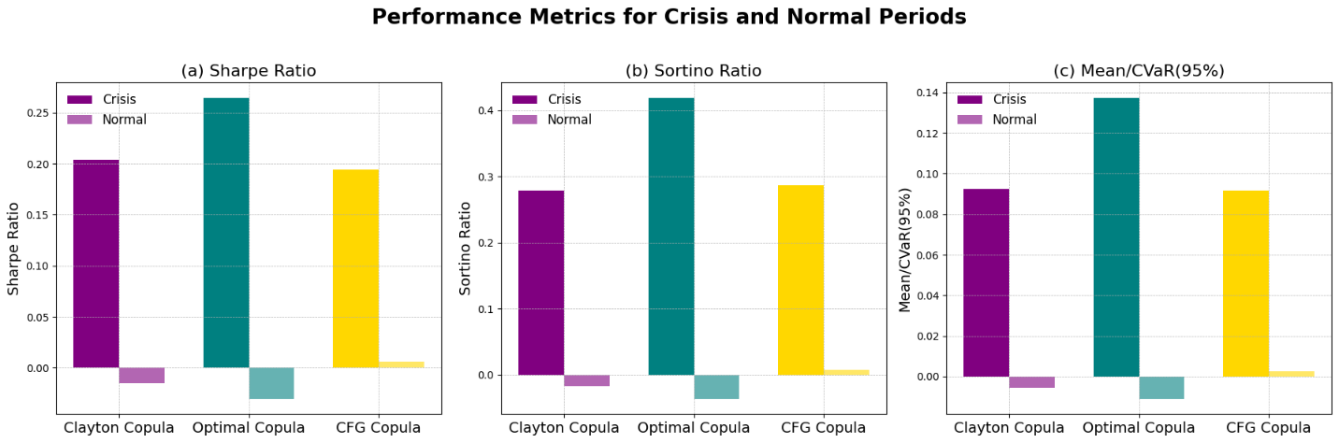

**Figure 11.** Average monthly performance in crisis and normal periods.

Note: This figure shows the performance of three strategies during ‘Crisis’ and ‘Normal’ periods. ‘Crisis’ is defined as the extreme periods of the CSI 300 stock market index returns on our entire sample (96 months out of 233) and ‘Normal’ consists of the remaining sub-periods.

# **6. Conclusion**

Pairs trading has become a widely adopted market-neutral trading strategy that seeks to generate profits irrespective of overall market movements. The strategy was pioneered in the 1980s by Gerry Bamberger and the quantitative trading team led by Nunzio Tartaglia at Morgan Stanley (Bookstaber, 2007). Notably, before its eventual collapse, Long-Term Capital Management (LTCM) also engaged in pairs trading strategies (Lowenstein, 2000).

Research by Gatev et al. (2006) demonstrated that a simple pairs trading approach, specifically the distance method (DM), was profitable between 1962 and 2002. However, subsequent studies by Do and Faff (2010, 2012) reported a decline in profitability when transaction costs were taken into account. To enhance the effectiveness of pairs trading, later studies introduced more sophisticated methodologies. Vidyamurthy (2004) explored cointegration techniques, while Wu (2013) applied copula frameworks to improve strategy performance. Despite these advancements, limitations remain in terms of the range of stock pairs examined, the duration of sample periods, and the robustness of analytical methods used in these studies.

Given these considerations, this research aims to address several key questions within the context of a long-term study on the Chinese market. First, do pairs trading strategies that utilize advanced divergence and convergence models lead to increased profitability? Second, are these profits sustainable after accounting for transaction costs? Third, what specific risk factors are associated with these pairs trading strategies? Finally, how do these strategies perform during periods of significant market turbulence? By investigating these questions, the study seeks to contribute to a deeper understanding of the efficacy and resilience of sophisticated pairs trading strategies in evolving market conditions.

Our study investigates the performance of various pairs trading strategies, specifically comparing the distance and copula methods, using daily stock data from the Chinese market over the period from January 2005 to December 2024. Incorporating a time-varying series of trading costs, we find that the Distance Method consistently delivers higher monthly returns than the copula-based approach. Across both economic and risk-adjusted metrics, the copula method lags behind the DM, which outperforms it on both counts.

Additionally, we observe that the market’s excess return does not fully explain the returns generated by these strategies, underscoring their market-neutral characteristics. This market neutrality is appealing to practitioners who seek alternative strategies for mitigating market risk, and it supports the academic perspective that pairs trading can serve as a valuable diversifier in investment portfolios. Our findings provide evidence that the DM’s economic and risk-adjusted performance are notably higher during periods of market turbulence. Consequently, incorporating such strategies into investment portfolios during crisis periods can serve dual purposes: reducing downside risk and capturing alpha. This highlights the potential for pairs trading to add resilience to portfolios in challenging market environments.

Although the copula method exhibits slightly weaker performance compared to the distance method, certain attributes of the copula strategy merit further consideration. Firstly, while DM strategies have recently experienced a decline in trading opportunities, the copula method has remained consistent in generating such opportunities. This consistency suggests that the factors leading to reduced trade frequency in other methods have not adversely affected the copula approach, making it a reliable alternative to less sophisticated strategies. It also indicates that, although market participants may have exploited the arbitrage opportunities identified by simpler methods—resulting in fewer available trades—the copula method continues to provide a steady stream of trading possibilities. Secondly, the copula method achieves returns on its converged trades that are comparable to those of other strategies. However, its relatively high proportion of unconverged trades offsets a significant portion of these profits. To enhance overall performance, it is essential to increase the ratio of converged trades or to limit the losses from unconverged trades. This improvement can be accomplished by implementing a stop-loss mechanism to cap potential losses or by optimizing the formation and trading periods to better capture profitable opportunities. Thirdly, the unconverged trades within the copula method demonstrate higher risk-adjusted performance than those of any other strategy. This superior performance further incentivizes the adoption of the copula approach, as it suggests a more efficient handling of trades that do not converge. Lastly, our findings reveal that the student-t copula emerges as the most suitable model for fitting the dependence structure among stock pairs in pairs trading on the Chinese market. The preference for the student-t copula stems from its flexibility in modeling both positive and negative correlations, as well as its capacity to account for fat tails (leptokurtosis) in the distribution of returns. This characteristic is particularly valuable in capturing the extreme co-movements often observed in financial markets. Consequently, we emphasize the advantage of employing copula methods, especially the student-t copula, to flexibly model the dependence structures and marginal distributions across stock pairs. This approach enhances the ability to identify and exploit trading opportunities that may be overlooked by traditional methods.

We have developed a computationally efficient copula-based pairs trading strategy that integrates elements of both the Distance Method and copula techniques. In our approach, we use the Sum of Squared Differences to identify stock pairs and select a suitably parsimonious fit for each pair from a variety of marginal and copula models. This design emphasizes ease of implementation, catering to practitioners for whom speed and computational efficiency are essential considerations in trading strategy execution (Clark, 2012; Angel, 2014; Brogaard et al., 2014).

Future research into the application of copulas in pairs trading could focus on evaluating the out-of-sample performance of a strategy that relies solely on copulas for pair selection. Such an investigation could shed light on whether the enhanced structure offered by copulas is substantial enough to warrant the additional computational resources they require.

In conclusion, pairs trading strategies remain profitable and robust, particularly in volatile market environments. While the profitability of distance-based strategies has shown signs of decline in recent years, the copula-based approach has demonstrated stability. Given these findings, the copula method presents a promising alternative and deserves further exploration by both practitioners and the academic community for its potential to add value in pairs trading strategies.

# **Reference**

Andrade, S., Di Pietro, V. and Seasholes, M., Understanding the profitability of pairs trading. Unpublished working paper, UC Berkeley, Northwestern University, 2005.

Angel, J., When finance meets physics: The impact of the speed of light on financial markets and their regulation. Financ. Rev., 2014, 49(2), 271–281.

Bogomolov, T., Pairs trading based on statistical variability of the spread process. Quant. Finance, 2013, 13(9), 1411–1430.

Bookstaber, R.,ADemon ofOur Own Design, 2007 (Wiley: Hoboken, NJ).

Bowen, D.A. and Hutchinson, M.C., 2016. Pairs trading in the UK equity market: Risk and return. The European Journal of Finance, 22(14), pp.1363-1387.

Brogaard, J., Hendershott,T. andRiordan,R., High-frequency trading and price discovery. Rev. Financ. Stud., 2014, 27(8), 2267–2306.

Broussard, J.P. and Vaihekoski, M., Profitability of pairs trading strategy in an illiquid market with multiple share classes. J. Int. Financ. Markets, Inst. Money, 2012, 22(5), 1188–1201.

Carhart, M.M., On persistence in mutual fund performance. J. Finance, 1997, 52(1), 57–82.

Chu, B., Recovering copulas from limited information and an application to asset allocation. J. Bank. Financ., 2011, 35(7), 1824–1842.

Clark, C., How to keep markets safe in the era of high-speed trading. Working Paper No. 303, Federal Reserve Bank of Chicago, 2012.

Creamer, G. and Freund, Y., Automated trading with boosting and expert weighting. Quant. Finance, 2010, 10(4), 401–420.

Da Silva, F.A.S., Ziegelmann, F.A. and Caldeira, J.F., 2023. A pairs trading strategy based on mixed copulas. The Quarterly Review of Economics and Finance, 87, pp.16-34.

Dempster, M.A.H. and Jones, C.M., A real-time adaptive trading system using genetic programming. Quant. Finance, 2001, 1(4), 397–413.

Do, B. and Faff, R., Are pairs trading profits robust to trading costs? J. Financ. Res., 2012, 35(2), 261–287.

Do, B. and Faff, R., Does simple pairs trading still work? Financ. Anal. J., 2010, 66(4), 83–95.

Eling, M., Does the measure matter in the mutual fund industry? Financ. Anal. J., 2008, 64(3), 54–66.

Fama, E.F. and French, K.R., A five-factor asset pricing model. J. Financ. Econ., 2015, 116(1), 1–22.

Gatev, E., Goetzmann, W.N. and Rouwenhorst, K.G., Pairs trading: Performance of a relative-value arbitrage rule. Rev. Financ. Stud., 2006, 19(3), 797–827.

Gupta, K. and Chatterjee, N., 2020. Selecting stock pairs for pairs trading while incorporating lead–lag relationship. Physica A: Statistical Mechanics and its Applications, 551, p.124103.

Huck, N., Pairs selection and outranking: An application to the S&P 100 index. Eur. J. Oper. Res., 2009, 196(2), 819–825.

Huck, N., Pairs trading and outranking: The multi-step-ahead forecasting case. Eur. J. Oper. Res., 2010, 207(3), 1702–1716.

Jacobs, H. and Weber, M., On the determinants of pairs trading profitability. J. Financ. Markets, 2015, 23, 75–97.

Joe, H., Multivariate Models and Dependence Concepts, 1997 (Chapman & Hall: London).

Longin, F. and Solnik, B., Is the correlation in international equity returns constant: 1960–1990? J. Int. Money Finance, 1995, 14(1), 3–26.

Low, R.K.Y., Alcock, J., Faff, R. and Brailsford, T., Canonical vine copulas in the context of modern portfolio management: Are they worth it? J. Bank. Financ., 2013, 37(8), 3085–3099.

Lowenstein, R., When Genius Failed: The Rise and Fall of Long-term Capital Management, 2000 (Random House: New York).

Miao, J. and Laws, J., 2016. Profitability of a simple pairs trading strategy: recent evidences from a global context. International Journal of Theoretical and Applied Finance, 19(04), p.1650023.

Okimoto, T., Asymmetric increasing trends in dependence in international equity markets. J. Bank. Financ., 2014, 46, 219–232.

Patton, A.J., On the out-of-sample importance of skewness and asymmetric dependence for asset allocation. J. Financ. Econ., 2004, 2(1), 130–168.

Perlin, M.S., Evaluation of pairs-trading strategy at the Brazilian financial market. J. Derivatives Hedge Funds, 2009, 15(2), 122–136.

Pástor, L. and Stambaugh, R.F., Liquidity risk and expected stock returns. J. Political Econ., 2003, 111(3), 642–685.

Rad, H., Low, R.K.Y. and Faff, R., 2016. The profitability of pairs trading strategies: distance, cointegration and copula methods. Quantitative Finance, 16(10), pp.1541-1558.

Siburg, K.F., Stoimenov, P. and Wei, G.N.F., Forecasting portfolio-Value-at-Riskwith nonparametric lower tail dependence estimates. J. Bank. Financ., 2015, 54, 129–140.

Vidyamurthy, G., Pairs Trading: Quantitative Methods and Analysis, 2004 (Wiley: Hoboken, NJ).

Wei, G.N.F. and Scheffer, M., Mixture pair-copula-constructions. J. Bank. Financ., 2015, 54, 175–191.

Wu,Y., Pairs trading:Acopula approach. J. Derivatives Hedge Funds, 2013, 19(1), 12–30.

Xie, W. and Wu, Y., Copula-based pairs trading strategy. In Asian Finance Association (AsFA) 2013 Conference, Nanchang, Jiangxi, China, 2013.

Xie, W., LieW, R.Q., Wu, Y., and Zou, X., 2016. Pairs Trading with Copulas. The Journal of Trading, Summer 2016, pp. 41-52.

Xie, W., Liew, Q.R.,Wu, Y. and Zou, X., Pairs trading with copulas, 2014. Available at SSRN 2383185.

Yang, S.Y., Qiao, Q., Beling, P.A., Scherer, W.T. and Kirilenko, A.A., Gaussian process-based algorithmic trading strategy identification. Quant. Finance, 2015, 1–21.

Zeng, Z. and Lee, C.G., Pairs trading: Optimal thresholds and profitability. Quant. Finance, 2014, 14(11), 1881–1893.

Zhang, H. and Urquhart, A., 2019. Pairs trading across Mainland China and Hong Kong stock markets. International Journal of Finance & Economics, 24(2), pp.698-726.